

**The Campus Hub**

**Software Design Specification**

2021.11.03.

**Introduction to Software Engineering**

**2021fall_41_TEAM13**

Team Leader NaHyeon-Oh

Team Member GangMin-Lee

SangMin-Han

JongWon-Heo

SoHee-Yun

Ngzhiwei

JeongAh-Lee

**CONTENTS**

1. Preface 10

1.1. Objective 10

1.2. Readership 10

1.2.1. User 10

1.2.2. System 10

1.3. Document Structure 10

1.3.1. Introduction 11

1.3.2. System Architecture 11

1.3.3. Protocol Design 11

1.3.4. Database Design 11

1.3.5. Testing Plan 11

1.3.6. Development Plan 11

1.3.7. Index 12

1.4. Document History 12

2. Introduction 13

2.1. Objective 13

2.2. Applied Diagrams 13

2.2.1. Unified Modeling Language (UML) 13

2.2.2. Use case Diagram 13

2.2.3. Sequence Diagram 14

2.2.4. Class Diagram 14

2.2.5. Context Diagram 14

2.2.6. Entity Relationship Diagram (ERD) 15

2.2.7. Package Diagram 15

2.2.8. Deployment Diagram 15

2.3. Applied Tools 16

2.3.1. Microsoft PowerPoint 16

2.3.2. ERD Plus 16

2.3.3. Draw.io 16

2.4. Project Scope 16

2.5. References 17

3. System Architecture - Overall 18

3.1. Objectives 18

3.2. System Organization 18

3.2.1. Context Diagram 18

3.2.2. Sequence Diagram 19

3.2.3. Use Case Diagram 19

4. System Architecture - Frontend 21

4.1. Objectives 21

4.2. Subcomponents 21

4.2.1. Entering the Campus Hub 21

4.2.1.1. Attributes 21

4.2.1.2. Methods 21

4.2.1.3. Class Diagram 21

4.2.1.4. Sequence Diagram 22

4.2.2. Profile 23

4.2.2.1. Attributes 23

4.2.2.2. Methods 24

4.2.2.3. Class Diagram 24

4.2.2.4. Sequence Diagram 24

4.2.3. Space movement 25

4.2.3.1. Attributes 25

4.2.3.2. Methods 25

4.2.3.3. Class Diagram 26

4.2.3.4. Sequence Diagram 26

4.2.4. Upload file 27

4.2.4.1. Attributes 27

4.2.4.2. Methods 27

4.2.4.3. Class Diagram 27

4.2.4.4. Sequence Diagram 28

4.2.5. Chat 29

4.2.5.1. Attributes 29

4.2.5.2. Methods 29

4.2.5.3. Class Diagram 29

4.2.5.4. Sequence Diagram 30

4.2.6. Hub 31

4.2.6.1. Attributes 31

4.2.6.2. Methods 31

4.2.6.3. Class Diagram 31

4.2.6.4. Sequence Diagram 31

4.2.7. Game 32

4.2.7.1. Attributes 32

4.2.7.2. Methods 32

4.2.7.3. Class Diagram 32

4.2.7.4. Sequence Diagram 33

4.2.8. Movie 34

4.2.8.1. Attributes 34

4.2.8.2. Methods 34

4.2.8.3. Class Diagram 34

4.2.8.4. Sequence Diagram 35

4.2.9. Beanbag 36

4.2.9.1. Attributes 36

4.2.9.2. Methods 36

4.2.9.3. Class Diagram 36

4.2.9.4. Sequence Diagram 36

4.2.10. Classroom 37

4.2.10.1. Attributes 37

4.2.10.2. Methods 38

4.2.10.3. Class Diagram 38

4.2.10.4. Sequence Diagram 38

4.2.11. Attendance 39

4.2.11.1. Attributes 39

4.2.11.2. Methods 39

4.2.11.3. Class Diagram 39

4.2.11.4. Sequence Diagram 40

4.2.12. Screenboard 40

4.2.12.1. Attributes 40

4.2.12.2. Methods 41

4.2.12.3. Class Diagram 41

4.2.12.4. Sequence Diagram 41

4.2.13. Desk 42

4.2.13.1. Attributes 42

4.2.13.2. Methods 42

4.2.13.3. Class Diagram 43

4.2.13.4. Sequence Diagram 43

4.2.14. Automatic class enter 44

4.2.14.1. Attributes 44

4.2.14.2. Methods 44

4.2.14.3. Class Diagram 44

4.2.14.4. Sequence Diagram 45

4.2.15. Reservation 45

4.2.15.1. Attributes 45

4.2.15.2. Methods 45

4.2.15.3. Class Diagram 46

4.2.15.4. Sequence Diagram 46

4.2.16. Office Hour 47

4.2.16.1. Attributes 47

4.2.16.2. Methods 47

4.2.16.3. Class Diagram 48

4.2.16.4. Sequence Diagram 48

4.2.17. Counseling 49

4.2.17.1. Attributes 49

4.2.17.2. Methods 49

4.2.17.3. Class Diagram 49

4.2.17.4. Sequence Diagram 49

4.2.18. Bookshelf in classroom 50

4.2.18.1. Attributes 50

4.2.18.2. Methods 50

4.2.18.3. Class Diagram 51

4.2.18.4. Sequence Diagram 52

4.2.19. Elevator 53

4.2.19.1. Attributes 53

4.2.19.2. Methods 54

4.2.19.3. Class Diagram 54

4.2.19.4. Sequence Diagram 55

4.2.20. Bookshelves in Library 55

4.2.20.1. Attributes 55

4.2.20.2. Methods 56

4.2.20.3. Class Diagram 56

4.2.20.4. Sequence Diagram 57

4.2.21. Posting space 58

4.2.21.1. Attributes 58

4.2.21.2. Methods 59

4.2.21.3. Class Diagram 59

4.2.21.4. Sequence Diagram 59

4.2.22. Reading room 60

4.2.22.1. Attributes 60

4.2.22.2. Methods 61

4.2.22.3. Class Diagram 61

4.2.22.4. Sequence Diagram 62

4.2.23. Study room 62

4.2.23.1. Attributes 62

4.2.23.2. Methods 63

4.2.23.3. Class Diagram 63

4.2.23.4. Sequence Diagram 64

4.2.24. Exhibition 65

4.2.24.1. Attributes 65

4.2.24.2. Methods 66

4.2.24.3. Class Diagram 66

4.2.24.4. Sequence Diagram 67

4.2.25. Event 69

4.2.25.1. Attributes 69

4.2.25.2. Methods 69

4.2.25.3. Class Diagram 69

4.2.25.4. Sequence Diagram 69

5. System Architecture - Backend 70

5.1. Objectives 70

5.2. Overall Architecture 71

5.3. Subcomponent 71

5.3.1. Server 71

5.3.1.1. Class Diagram 71

5.3.1.2. Sequence Diagram 72

5.3.2. Hub 73

5.3.2.1. Class Diagram 73

5.3.2.2. Sequence Diagram 73

5.3.3. Classroom 74

5.3.3.1. Class Diagram 74

5.3.3.2. Sequence Diagram 75

5.3.4. Library 77

5.3.4.1. Class Diagram 77

5.3.4.2. Sequence Diagram 78

5.3.5. Exhibition Hall 79

5.3.5.1. Class Diagram 79

5.3.5.2. Sequence Diagram 80

6. Protocol Design 81

6.1. Objective 81

6.2. JSON 81

6.3. Details 81

6.3.1. Authentication 81

6.3.2. Student information for class 81

6.3.2.1. Planned Class 81

6.3.2.2. Class Attendance 82

6.3.3. Movie in Hub 83

6.3.4. Book Information 84

6.3.4.1. Bookshelves in Library 84

6.3.4.2. Get Book Information 85

6.3.4.3. Bookshelf in Classroom 85

6.3.4.4. Reference books in Classroom 86

6.3.5. Posting space 87

6.3.5.1. Read(All) 87

6.3.5.2. Read(Detail) 88

6.3.5.3. Create 88

6.3.5.4. Delete 89

6.3.5.5. Update 90

6.3.6. Exhibition Hall 91

6.3.6.1. Select exhibition 91

6.3.6.2. Enter exhibition and enjoy 91

6.3.6.3. Create work 92

6.3.6.4. Delete work 93

6.3.6.5. Update 94

7. Database Design 95

7.1. Objective 95

7.2. ER Diagram 95

7.2.1. Entities 96

7.2.1.1. User 96

7.2.1.2. Classroom 97

7.2.1.3. Hub 98

7.2.1.4. Exhibition Hall 98

7.2.1.5. Library 99

7.2.2. Relational Schema 100

7.2.3. SQL DDL 101

7.2.3.1. Users 101

7.2.3.2. Avatar 102

7.2.3.3. Logout 102

7.2.3.4. Login 103

7.2.3.5. Chat 103

7.2.3.6. Hub 103

7.2.3.7. Classroom 104

7.2.3.8. Counseling 104

7.2.3.9. Attendance 105

7.2.3.10. Bookshelf 105

7.2.3.11. Office Hour 106

7.2.3.12. QA1 106

7.2.3.13. Library 106

7.2.3.14. Books 107

7.2.3.15. Rooms 107

7.2.3.16. Exhibition 108

7.2.3.17. Ongoing 108

7.2.3.18. Vote 108

7.2.3.19. QA2 109

8. Testing Plan 110

8.1. Objective 110

8.2. Testing Policy 110

8.2.1. Development Testing 110

8.2.1.1. Performance 110

8.2.1.2. Reliability 110

8.2.1.3. Usability 111

8.2.1.4. Security 111

8.2.2. Release Testing 111

8.2.3. User Testing 112

8.2.4. Testing Case 113

9. Development Plan 115

9.1. Objective 115

9.2. Frontend Environment 115

9.2.1. Photoshop 115

9.2.2. Blender 115

9.2.3. Unity2019 116

9.2.4. UdonSharp 117

9.3. Backend Environment 117

9.3.1. Github 117

9.3.2. MySQL 118

9.3.3. Youtube 118

9.3.4. Django 119

9.4. Schedule 119

10. Index 120

10.1. Table Index 120

10.2. Figure Index 120

1. Preface
   1. Objective

In this chapter, we define the expected readership of this document and describe its structure and version history. Document history shows a rationale for the creation of a new version and a summary of the changes made in each version done by each team member.

* 1. Readership

Team 13 designs and implements the functions of the Campus hub service according to this specification. Then, team members of Team 13, professors, and TAs in the Introduction to Software Engineering class are expected be the main readers. Furthermore, students or staff related to Sungkyunkwan University who have access to this system can also become readers.

* + 1. User

The expected reader of user requirements is users of the system. Therefore, from the user's point of view, we explain the requirements in an easy-to-understand manner, refraining from using technical terms and rather using visual materials such as diagrams with the description in natural language..

* + 1. System

System requirements are a structured language expression of system functions and constraints. It shall be written systematically so that it can be used as a reference material during the development process for developers or used in contracts with customers. Therefore, this is mainly for developers, Team 13 members.

* 1. Document Structure

Before starting each chapter describing our system, we introduce what each chapter covers in this chapter.

* + 1. Introduction

This chapter mainly includes the instructions of several diagrams and tools applied to design our project. Additionally, references we have been used for this design specification regarding our system are also described in this chapter.

* + 1. System Architecture

This chapter suggests how the architectures of our system are produced in three divided description parts. You can get overall insight about the campus hub by context diagram, sequence diagram and use case diagram of our system. The system is subdivided by several classes. For each class, we introduce attributes and methods and show class diagram and sequence diagram for frontend perspective and backend perspective.

* + 1. Protocol Design

We describe design of protocols which used for communication of entities. The contents are focused on the classes in subsystem where communication is needed. For each class, we describe request and response protocols by tabular type.

* + 1. Database Design

In this chapter, we describe how structures are organized and the relationships are constructed for the system data. data structure of system and process

* + 1. Testing Plan

In this chapter, the testing plan of our system is illustrated. The test will be progressed by three phases which are development, user and release test. You can check how our system is tested for performance, reliability, usability, maintainability and security. Also, we define testing policy and test case.

* + 1. Development Plan

In this chapter, the tools and technologies in frontend environments and backend environments for our system is introduced and described how those are utilized. At the last section in this chapter, you can see the schedule to develop our system.

* + 1. Index

In this chapter, you can check all tables and figures used to describe the product at a glance.

* 1. Document History

[Table 1] Document History

| **Date** | **Version** | **Description** | **Writer** |
| --- | --- | --- | --- |
| 2021/11/03 | 0.1 | Style and overview | NaHyeon-Oh |
| 2021/11/11 | 1.0 | Add contents of 5.3.2 – 5.3.5 | Ngzhiwei |
| 2021/11/12 | 1.1 | Add contents of 6.3.5 – 6.3.6 | JeongAh-Lee |
| 2021/11/12 | 1.2 | Add contents of 6 – 6.3.4 | NaHyeon-Oh |
| 2021/11/12 | 1.2.1 | Assemble and organize | NaHyeon-Oh |
| 2021/11/12 | 1.3 | Add contents of 4.2.10–4.2.18 | Sangmin-Han |
| 2021/11/12 | 1.3 | Add contents of 4.2.19–4.2.25 | Sohee-Yoon |
| 2021/11/12 | 1.3 | Add contents of 4.2.1–4.2.9 | Jongwon-Heo |
| 2021/11/12 | 1.3 | Add contents of 5 – 5.3.1 | Gangmin-Lee |
| 2021/11/12 | 1.3 | Reflect feedback of 6 – 6.1.3 | NaHyeon-Oh |
| 2021/11/15 | 1.4 | Assemble and organize | Sangmin-Han |
| 2021/11/16 | 1.5 | Add contents of 9 – 9.2.4 | Gangmin-Lee |
| 2021/11/18 | 1.6 | Add contents of 1.3.2 – 1.3.6 | Sangmin-Han |
| 2021/11/18 | 1.7 | Add contents of 7.2.3 – 7.2.3.19 | NaHyeon-Oh |
| 2021/11/19 | 1.8 | Add contents of 7.1 – 7.2.2 | Ngzhiwei |
| 2021/11/19 | 1.8 | Add contents of 8.2.1.4 – 8.2.4 | Jongwon-Heo |
| 2021/11/19 | 1.8 | Add contents of 9.3 – 9.4 | JeongAh-Lee |
| 2021/11/19 | 1.8 | Add contents of 8.1 – 8.2.3 | Sohee-Yoon |
| 2021/11/19 | 1.8.1 | Assemble and organize | Sangmin-Han |

1. Introduction
   1. Objective

This document is a Software Design Specification (SDS) for providing The Campus Hub. This system is designed and implemented by Team 13 of the Introduction to Software Engineering at Sungkyunkwan University. The requirements for this are summarized, analyzed, and the system is designed and implemented based on the contents described in this document.

* 1. Applied Diagrams
     1. Unified Modeling Language (UML)

UML is an acronym that stands for Unified Modeling Language. Simply put, UML is a modern approach to modeling and documenting software. In fact, it’s one of the most popular business process modeling techniques. UML is a common language for business analysts, software architects and developers used to describe, specify, design, and document existing or new business processes, structure and behavior of artifacts of software systems. UML can be applied to diverse application domains (e.g., banking, finance, internet, aerospace, healthcare, etc.) It can be used with all major object and component software development methods and for various implementation platforms (e.g., J2EE, .NET). It is based on diagrammatic representations of software components. As the old proverb says: “a picture is worth a thousand words”. By using visual representations, we are able to better understand possible flaws or errors in software or business processes.

* + 1. Use case Diagram

A cornerstone part of the system is the functional requirements that the system fulfills. Use Case diagrams are used to analyze the system’s high-level requirements. These requirements are expressed through different use cases. We notice three main components of this UML diagram: Functional requirements – represented as use cases; a verb describing an action. Actors – they interact with the system; an actor can be a human being, an organization or an internal or external application. Relationships between actors and use cases – represented using straight arrows.

* + 1. Sequence Diagram

Sequence diagrams are probably the most important UML diagrams among not only the computer science community but also as design-level models for business application development. Lately, they have become popular in depicting business processes, because of their visually self-explanatory nature. As the name suggests, sequence diagrams describe the sequence of messages and interactions that happen between actors and objects. Actors or objects can be active only when needed or when another object wants to communicate with them. All communication is represented in a chronological manner.

* + 1. Class Diagram

A class diagram in the Unified Modeling Language (UML) is a type of static structure diagram that describes the structure of a system by showing the system's classes, their attributes, operations (or methods), and the relationships among objects. Since classes are the building block of objects, class diagrams are the building blocks of UML. The various components in a class diagram can represent the classes that will actually be programmed, the main objects, or the interactions between classes and objects. The class shape itself consists of a rectangle with three rows. The top row contains the name of the class, the middle row contains the attributes of the class, and the bottom section expresses the methods or operations that the class may use. Classes and subclasses are grouped together to show the static relationship between each object.

* + 1. Context Diagram

The system context diagram (also known as a level 0 DFD) is the highest level in a data flow diagram and contains only one process, representing the entire system, which establishes the context and boundaries of the system to be modeled. It identifies the flows of information between the system and external entities (i.e. actors). A context diagram is typically included in a requirements document. It must be read by all project stakeholders and thus should be written in plain language, so the stakeholders can understand items. The objective of the system context diagram is to focus attention on external factors and events that should be considered in developing a complete set of systems requirements and constraints. A system context diagram is often used early in a project to determine the scope under investigation. Thus, within the document. A system context diagram represents all external entities that may interact with a system. The entire software system is shown as a single process. Such a diagram pictures the system at the center, with no details of its interior structure, surrounded by all its External entities, interacting systems, and environments.

* + 1. Entity Relationship Diagram (ERD)

An entity relationship diagram (ERD) shows the relationships of entity sets stored in a database. An entity in this context is an object, a component of data. An entity set is a collection of similar entities. These entities can have attributes that define its properties. By defining the entities, their attributes, and showing the relationships between them, an ER diagram illustrates the logical structure of databases. Entity Relationship diagrams are used to sketch out the design of a database.

* + 1. Package Diagram

Package diagram is a sort of structure diagram showing the arrangement and organization of model elements. Package diagram can show both structure and dependencies between sub-systems or modules showing different views of a system. Package diagram can be used to simplify complex class diagrams, it can group classes into packages. A package is a collection of logically related UML element.

* + 1. Deployment Diagram

Deployment Diagram is a sort of structure diagram used in modeling the physical aspects of an object-oriented system. Deployment diagram shows the configuration of tun time processing nodes and the components that inhibit on them. They are usually used to model the static deployment of a system. They are crucial for visualizing, specifying, and documenting embedded, client/server, and distributed systems and also for managing executable systems through forward and reverse engineering. The diagram is a collection of vertices and arcs.

* 1. Applied Tools
     1. Microsoft PowerPoint

This is a tool that supports drawing text and figures. It is convenient to draw diagrams using various shapes. In addition, it is easy to edit because it works as full word-processor formatting (which is a tool for working with documents), graphic shapes with attached text for drawing diagrams and tables.

* + 1. ERD Plus

This is a web-based database modeling tool that lets you quickly and easily create Entity Relationship Diagrams (ERDs), Relational Schemas (Relational Diagrams), and Star Schemas (Dimensional Models).

* + 1. Draw.io

This is a free online diagramming software application for building diagramming applications. It also produces web-based diagramming technology and integrates with Google Drive and Dropbox. They produce draw.io, a web-based diagramming application built on mxGraph. It enables you to create flowcharts, UML, entity relation, network diagrams, mockups and more. In this paper, every diagram except ERDs is written by draw.io.

* 1. Project Scope

The purpose of this document is to outline and publish the requirement specification for our smart campus in Metaverse, the Campus Hub. Unlike many other existing virtual smart campuses out in the current market, the Campus Hub is at a whole new level when it comes to creating a unique and seemingly-real campus life for our students and professors. Especially during this period where schools, students, and teaching and non-teaching staff struggle to the changes in the post-pandemic approaches, the Campus Hub compensates and provides an alternative solution to the issues. Academically, the Campus Hub has virtual classrooms which will not only improve learning but more importantly, regain the level of comfort and convenience for teaching, learning, and interactions between students and professors. Apart from the academic side, non-academically, the Campus Hub has an exhibition hall, library, and hub in which each offers a new spectrum of learning, expanding non-academically horizons, and having fun.

The remainder of this software requirement specification document includes three chapters and indexes. The 3rd chapter provides a bird’s eye view of the Campus Hub, including its system interfaces, user interfaces, hardware interfaces, and more. Also, it includes brief descriptions of the Campus Hub’s functionalities. Furthermore, the chapter ends with some constraints which need to be adhered to and some assumptions and dependencies which need its equal considerations. In the 4th chapter, this document dives deeper into looking at the specific requirements, hardware and software interfaces and communication interfaces. Also, to provide a better understanding on the functional requirements, use case diagram, entity relationship diagram, and data flow diagram were put together to aid in the understanding of the Campus Hub from a diagrammatic perspective. Nonfunctional requirements, not described in the 3rd chapter, are described in this chapter. Last but not least, the 5th and final chapter talks about the system evolution. It provides a brief yet much-considered overview on the limitations and assumptions the Campus Hub may potentially face, and also, provides information on the evolution of hardware and change of user requirements.

All members contributed equally to the production of this document and we sincerely hope that you, the reader, can garner a better understanding of The Campus Hub through this document.

* 1. References
* Team 1. “Software Design Document”. SKKU, Last Modified: May. 24, 2020.  
  <https://github.com/skkuse/2020spring_41class_team1/blob/master/docs/SDD_TEAM1.pdf>
* Appleton, Brad. A Software Design Specification Template. N.d.
* P. Burke, K. Martin, D. Longtin. Software Design Specification for a One Runway Airport/Air Traffic Controller Simulation  
  <<https://www.academia.edu/29811493/SOFTWARE_DESIGN_SPECIFICATION_FOR_A_ONE_RUNWAY_AIRPORT_AIR_TRAFFIC_CONTROLLER_SIMULATION>>.
* <https://www.crunchbase.com/organization/draw-io>

1. System Architecture - Overall
   1. Objectives

In this chapter, we describe and show the organization of the system, ranging from the frontend design to the backend design of the application for the project.

* 1. System Organization
     1. Context Diagram

[Diagram 1] Context model

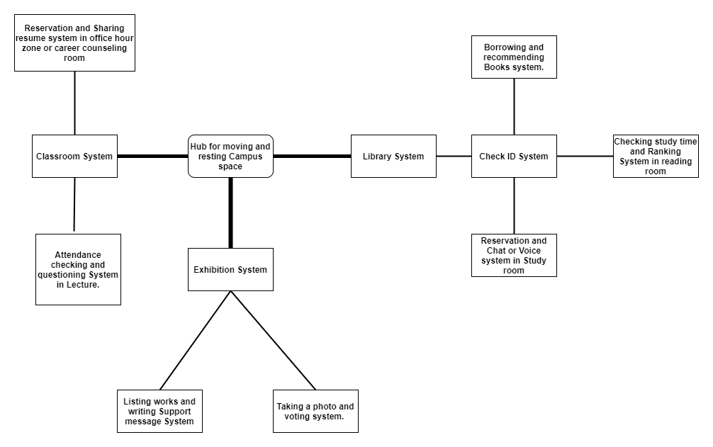

* + 1. Sequence Diagram

[Diagram 2] Sequence diagram

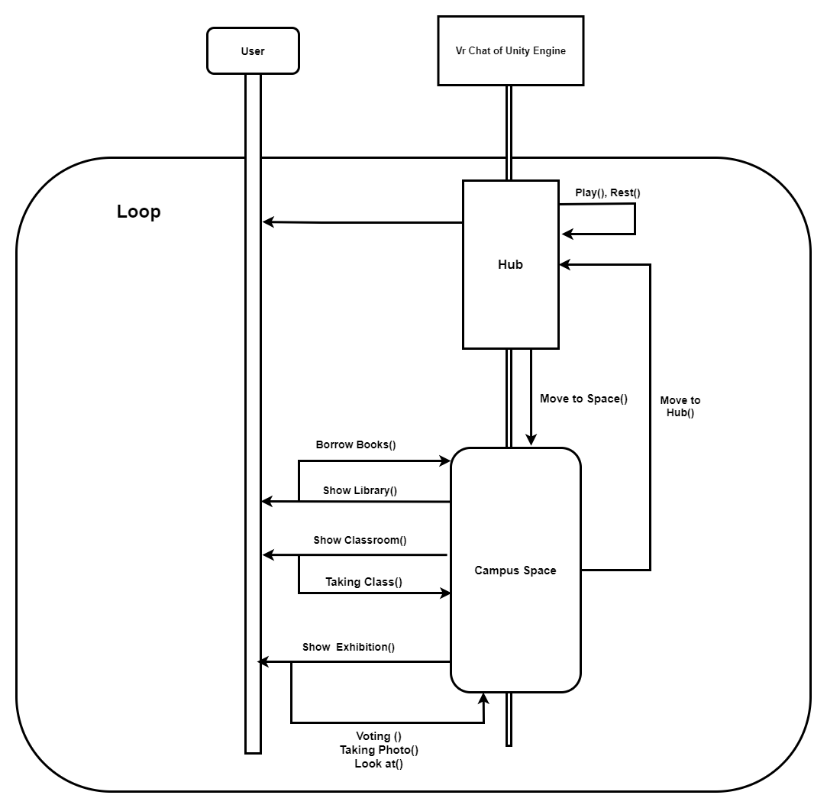

* + 1. Use Case Diagram

[Diagram 3] Use case diagram

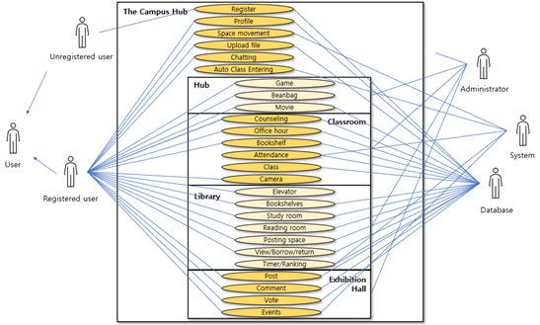

1. System Architecture - Frontend
   1. Objectives

This chapter describes structure, attributes and function of the frontend system and describe the relation of each component.

* 1. Subcomponents
     1. Entering the Campus Hub
        1. Attributes

These are the attributes that entering the campus hub object has.

* **User_id** : id of the user (email address)
* **Student_id** : student id of the user
* **Password** 
  + - 1. Methods

These are the methods that entering the campus hub class has.

* Save ID/Password()
* Get ID/Password()
* Check Student ID()
* Check ID/Password()
  + - 1. Class Diagram

[Diagram 4] Class diagram – Entering the campus hub

* + - 1. Sequence Diagram

[Diagram 5] Sequence diagram – Entering the campus hub

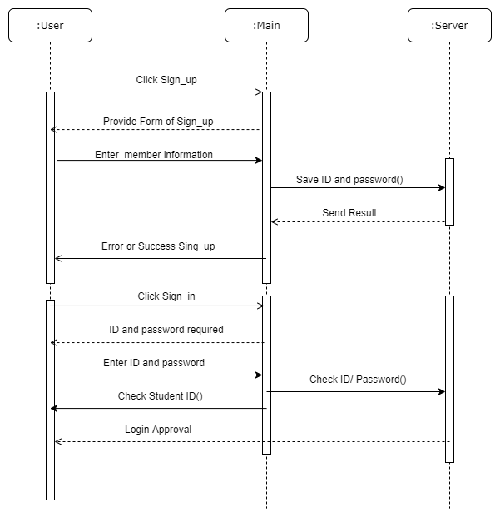

* + 1. Profile
       1. Attributes

These are the attributes that profile object has.

* **User_id** : id of the user (student ID)
* **Profile**
* **Avatar** 
  + - 1. Methods

These are the methods that profile class has.

* Set_profile()
* Get_profile()
* Change Profile()
* Set_Avatar()
* Get_Avatar()
* Change_Avatar()
  + - 1. Class Diagram

[Diagram 6] Class diagram – Profile

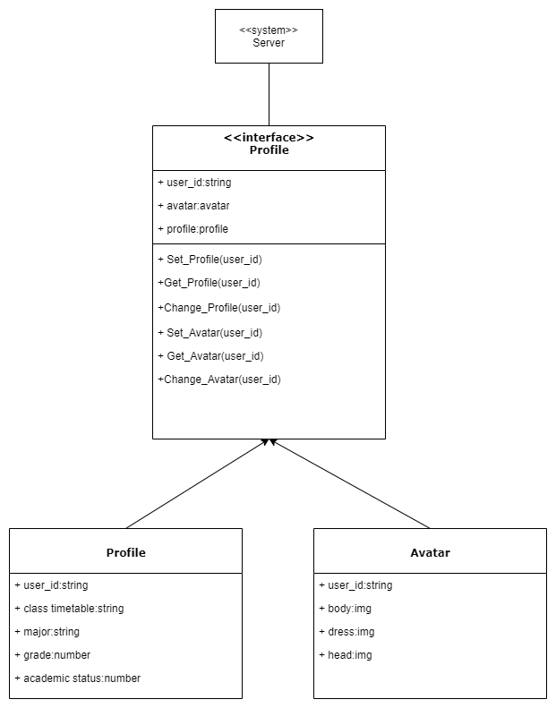

* + - 1. Sequence Diagram

[Diagram 7] Sequence diagram – Profile

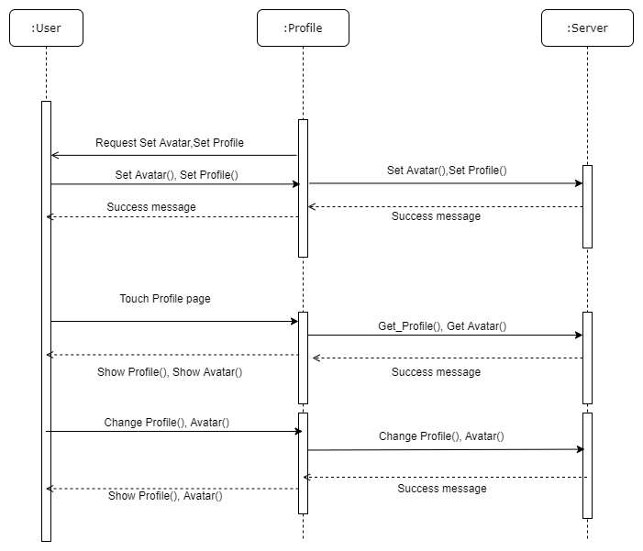

* + 1. Space movement
       1. Attributes

These are the attributes that space movement object has.

* **User_id**: id of the user (student ID)
* **Space**: one of the spaces (hub, classroom, library, exhibition)
  + - 1. Methods

These are the methods that space movement class has.

* Set_Space()
* Move_user()
  + - 1. Class Diagram

[Diagram 8] Class diagram – Space movement

* + - 1. Sequence Diagram

[Diagram 9] Sequence diagram – Space movement

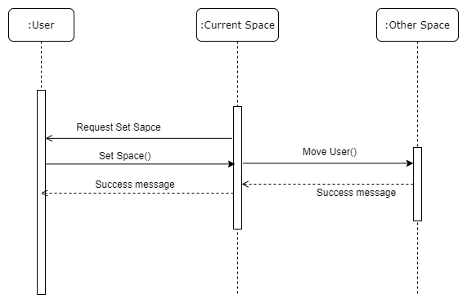

* + 1. Upload file
       1. Attributes

These are the attributes that upload file object has.

* **User_id**: id of the user (student ID)
* **URL**: url where the file saved at
  + - 1. Methods

These are the methods that upload file class has.

* Set_URL()
* Upload_URL()
* Get_Information()
* Delete_URL()
  + - 1. Class Diagram

[Diagram 10] Class diagram – Upload file

* + - 1. Sequence Diagram

[Diagram 11] Sequence diagram – Upload file

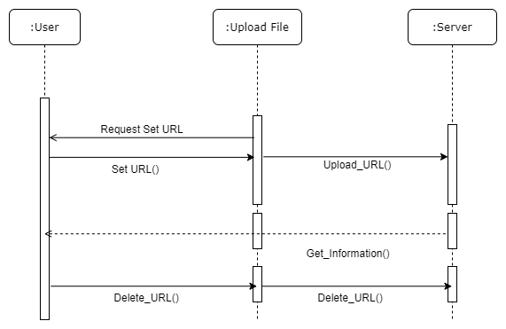

* + 1. Chat
       1. Attributes

These are the attributes that chat object has.

* **User_id**: id of the user (student ID)
* **Message**: means of communication as text or voice
  + - 1. Methods

These are the methods that chat class has.

* Matching_user()
* Get_Opinion()
* Start_Chat()
* Send_Chat()
  + - 1. Class Diagram

[Diagram 12] Class diagram – Chat

* + - 1. Sequence Diagram

[Diagram 13] Sequence diagram – Chat

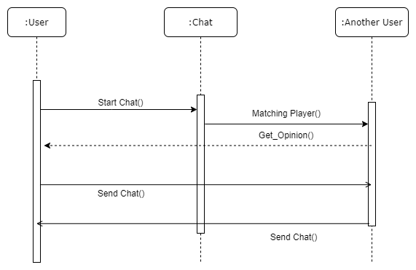

* + 1. Hub
       1. Attributes

These are the attributes that hub object has.

* **User id**: id of the user (student ID)
* **Space_key** 
  + - 1. Methods

These are the methods that hub class has.

* Connect_space()
* Select_space()
  + - 1. Class Diagram

[Diagram 14] Class diagram – Hub

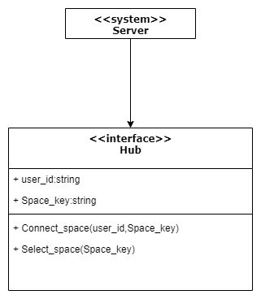

* + - 1. Sequence Diagram

[Diagram 15] Sequence diagram – Hub

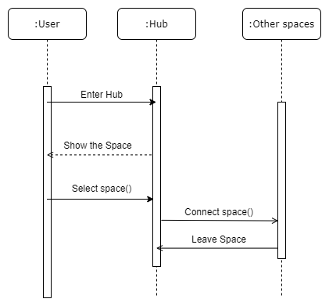

* + 1. Game
       1. Attributes

These are the attributes that game object has.

* **User id**: for matching user
* **Game key code**: for checking what game user select and show game for user
  + - 1. Methods

These are the methods that game class has.

* Show game()
* Matching Player()
* Quit Game()
  + - 1. Class Diagram

[Diagram 16] Class diagram – Game

* + - 1. Sequence Diagram

[Diagram 17] Sequence diagram – Game

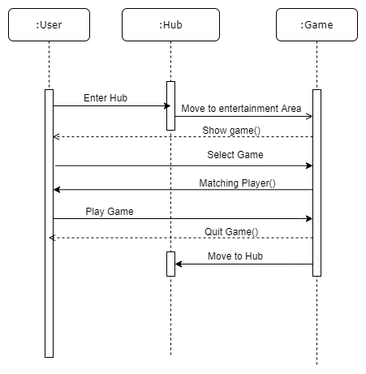

* + 1. Movie
       1. Attributes

These are the attributes that movie object has.

* **User Id**: for checking user watching movie
* **Movie URL**: it is need to for user
  + - 1. Methods

These are the methods that movie class has.

* Set_movie()
* Stop Movie()
  + - 1. Class Diagram

[Diagram 18] Class diagram – Movie

* + - 1. Sequence Diagram

[Diagram 19] Sequence diagram – Movie

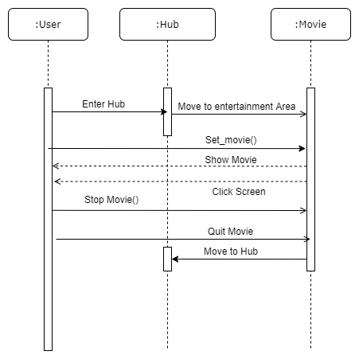

* + 1. Beanbag
       1. Attributes

These are the attributes that profile object has.

* **User id**: for checking user
  + - 1. Methods

These are the methods that profile class has.

* Set Beanbag()
* Get up()
  + - 1. Class Diagram

[Diagram 20] Class diagram – Beanbag

* + - 1. Sequence Diagram

[Diagram 21] Sequence diagram – Beanbag

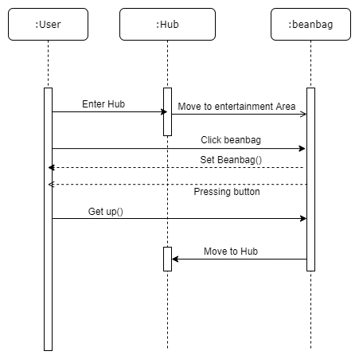

* + 1. Classroom

The classroom class deals with a space “Classroom” in general where a user can give a lecture with uploading file on screen board or take a lecture on his/her seat or using bookshelf, move to Counseling and Office Hour.

* + - 1. Attributes

These are the attributes that classroom object has.

* **User**: id of the user
* **Seat**: whether take a seat on the chair
* **Bookshelf**:bookshelf
* **CounselingDoor**: mean of entering and reserving counseling
* **OfficehourDoor**:mean of entering and reserving officehour
* **Desk**: desk
  + - 1. Methods

These are the methods that classroom class has.

* ReserveCounseling()
* ReserveOfficehour()
* GetInCounseling()
* GetInOfficehour()
  + - 1. Class Diagram

[Diagram 22] Class diagram – Classroom

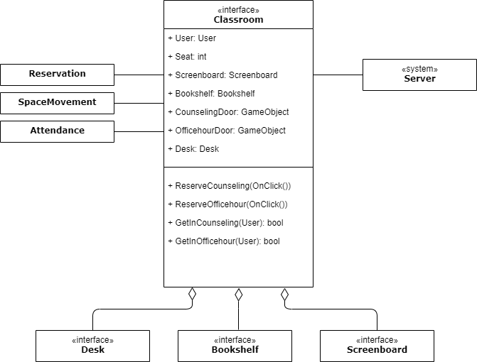

* + - 1. Sequence Diagram

[Diagram 23] Sequence diagram – Classroom

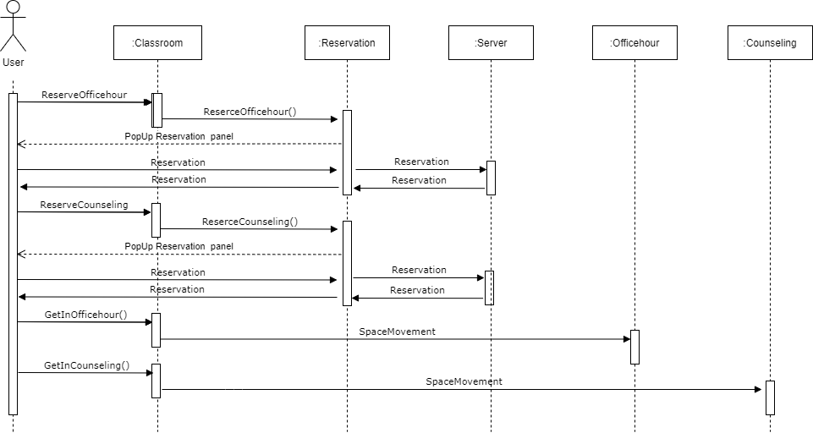

* + 1. Attendance

The attendance deals with attendance of the class of users. The information is automatically checked by real time.

* + - 1. Attributes

These are the attributes that attendance object has.

* **User id**: id of the user (student ID)
* **Attendance**: whether student participate the class
* **Time**: time when the class start
  + - 1. Methods

These are the methods that attendance class has.

* SetAttendance()
* GetAttendance()
  + - 1. Class Diagram

[Diagram 24] Class diagram – Attendance

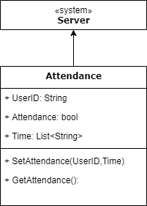

* + - 1. Sequence Diagram

[Diagram 25] Sequence diagram – Attendance

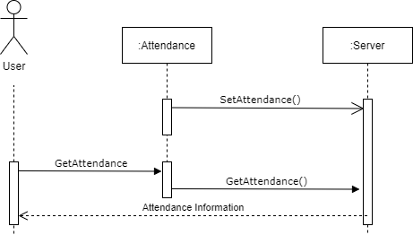

* + 1. Screenboard
       1. Attributes

These are the attributes that screenboard object has.

* **Screenboard**: a screen board panel to show uploaded file
* **Uploadframe**: a window user can insert url of file
* **FileURL**: a url of the file
  + - 1. Methods

These are the methods that screenboard class has.

* ClickScreen()
* EnterURL()
* UploadFile()
* ShowScreen()
  + - 1. Class Diagram

[Diagram 26] Class diagram – Screenboard

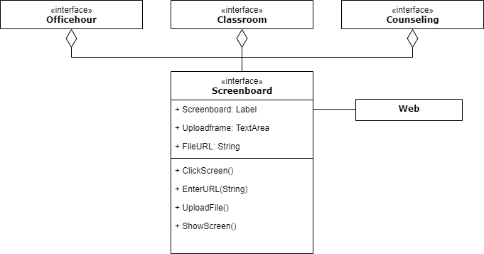

* + - 1. Sequence Diagram

[Diagram 27] Sequence diagram – Screenboard

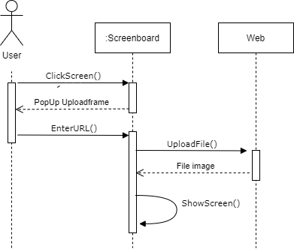

* + 1. Desk
       1. Attributes

These are the attributes that desk object has.

* **Desk**: a desk combined with a chair
* **Chair**: a chair where the users sit down
* **Seat**: whether someone use this desk
* **QuestionButton**: button for question
* **DeskCamera**: camera on the desk to change angle of the user to the screen board
  + - 1. Methods

These are the methods that desk class has.

* Occupy()
* Vacate()
* ClickQuestionButton()
* ChangeView()
  + - 1. Class Diagram

[Diagram 28] Class diagram – Desk

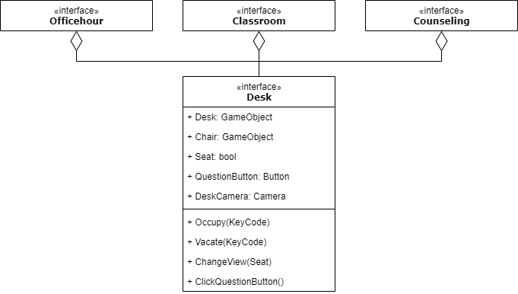

* + - 1. Sequence Diagram

[Diagram 29] Sequence diagram – Desk

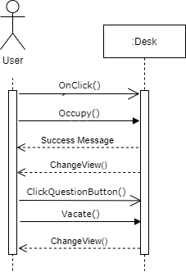

* + 1. Automatic class enter
       1. Attributes

These are the attributes that automatic class enter object has.

* **User id**: id of the user (student ID)
* **User timetable**: timetable of user in user’s profile
* **Class number**: each class has a unique number to identify the space to move
  + - 1. Methods

These are the methods that automatic class enter class has.

* GetUserID()
* GetTimetable()
* CheckTimetable()
* EnterClass()
  + - 1. Class Diagram

[Diagram 30] Class diagram – Automatic classroom enter

* + - 1. Sequence Diagram

[Diagram 31] Sequence diagram – Automatic classroom enter

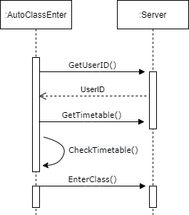

* + 1. Reservation
       1. Attributes

These are the attributes that reservation object has.

* **User id**: id of the user (student ID)
* **Timetable**: usable timetable
* **UsableTime**: to represent usable time for reservation
* **WhoReservate**: a window user can write booker’s id
* **Booker**: list of users who reserve the space
* **Reservation**: context of reservation time and people
  + - 1. Methods

These are the methods that reservation class has.

* ClickUsableTime()
* SetReservation()
* SaveReservation()
* GetReservation()
  + - 1. Class Diagram

[Diagram 32] Class diagram – Reservation

* + - 1. Sequence Diagram

[Diagram 33] Sequence diagram – Reservation

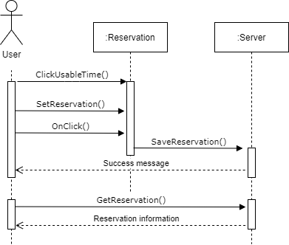

* + 1. Office Hour
       1. Attributes

These are the attributes that office hour object has.

* **Screenboard**: id of the user (email address)
* **Desk**: desk
* **Door**: door of office hour zone
* **InConversation**: whether some student users enter office hour zone
  + - 1. Methods

These are the methods that office hour class has.

* OpenDoor()
* CloseDoor()
* InConversationOn()
* InConversationOff()
  + - 1. Class Diagram

[Diagram 34] Class diagram – Officehour

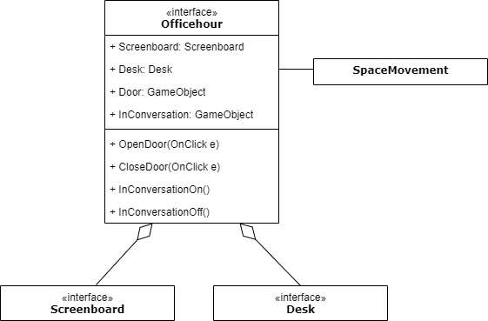

* + - 1. Sequence Diagram

[Diagram 35] Sequence diagram – Officehour

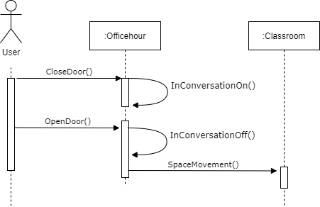

* + 1. Counseling
       1. Attributes

These are the attributes that counseling object has.

* **Screenboard**: screenboard
* **Desk**: desk
* **Door**: means of entering classroom
  + - 1. Methods

These are the methods that counseling class has.

* OpenDoor()
* CloseDoor()
  + - 1. Class Diagram

[Diagram 36] Class diagram – Counseling

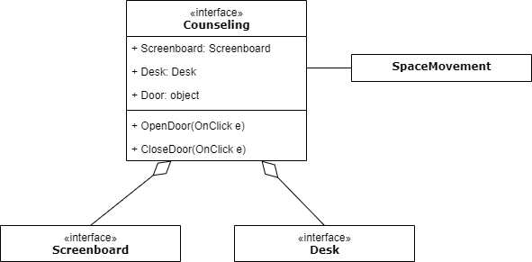

* + - 1. Sequence Diagram

[Diagram 37] Sequence diagram – Counseling

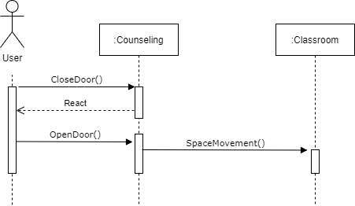

* + 1. Bookshelf in classroom
       1. Attributes

These are the attributes that bookshelf in classroom object has.

* **SearchPanel**: window where user can enter book name
* **SearchTextArea**: space to enter the book name in search panel
* **Searchedbook**: book name user searched
* **BookList:** result of searching
* **SearchResult**: a dropdown space to show results of searching
* **Textbook**: textbook of the class
* **Relatedbook**: related books of textbook.
* **Bookshelf**: panel of bookshelf
* **TextBookLabel**: show textbook
* **RelatedBookLabel**: show related book
  + - 1. Methods

These are the methods that bookshelf in classroom class has.

* ClickBookshelf()
* PopUpSearch()
* GetBookList()
* SearchBook()
* ShowSearchResult()
* ChooseBook()
* SearchRelatedBook()
* ShowBookshelf()
  + - 1. Class Diagram

[Diagram 38] Class diagram – Bookshelf in classroom

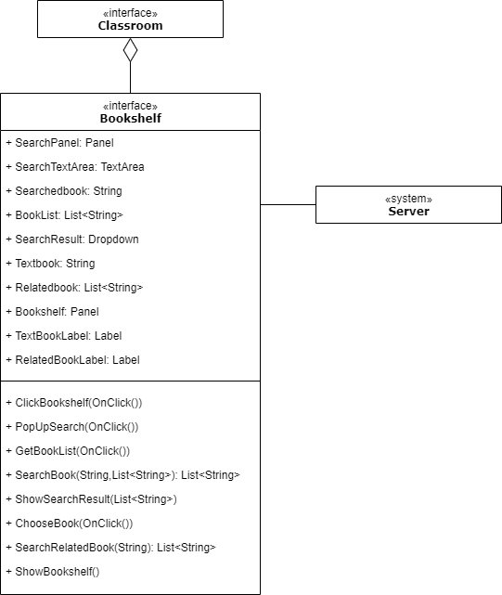

* + - 1. Sequence Diagram

[Diagram 39] Sequence diagram – Bookshelf in classroom

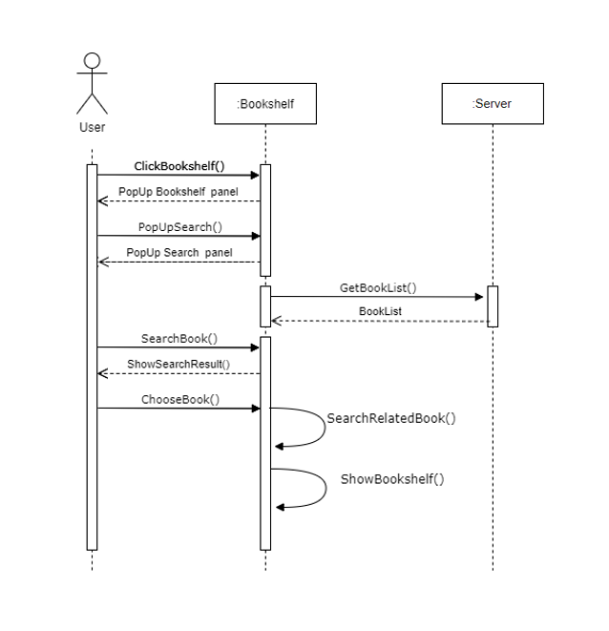

* + 1. Elevator
       1. Attributes

These are the attributes that elevator object has.

* **floor**: current floor in library
* **upbtn**: button to go up
* **downbtn**: button to go down
* **openbtn**: button to open the elevator
* **closebtn**: button to close the elevator
* **btns**: button to choose the number of floors
  + - 1. Methods

These are the methods that elevator class has.

* Come()
* Open()
* Close()
* Move(btns)
  + - 1. Class Diagram

[Diagram 40] Class diagram – Elevator

* + - 1. Sequence Diagram

[Diagram 41] Sequence diagram – Elevator

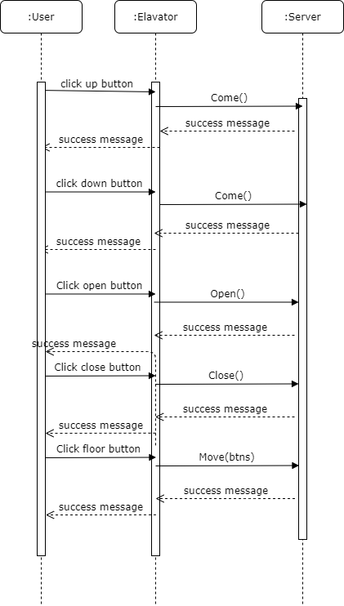

* + 1. Bookshelves in Library
       1. Attributes

These are the attributes that bookshelves in library object has.

* **user_id**: id of the user (email address)
* **click**: whether user clicked bookshelves or not
* **searchbtn**: button to search a desired book
* **book**: book in the library
* **borrowbtn**: button to borrow book
* **returnbtn**: button to return book
* **availablebook**: book that can be rented
  + - 1. Methods

These are the methods that bookshelves in library class has.

* Show(click)
* Search(searchbtn, title)
* Borrow(borrowbtn, book_id)
* Return(returnbtn, book_id)
  + - 1. Class Diagram

[Diagram 42] Class diagram – Bookshelves in Library

* + - 1. Sequence Diagram

[Diagram 43] Sequence diagram – Bookshelves in Library

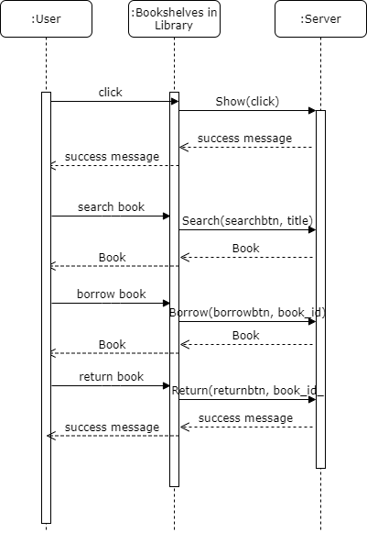

* + 1. Posting space
       1. Attributes

These are the attributes that posting space object has.

* **user_id**: id of the user (email address)
* **image**: url of image file where his/her post is uploaded
* **savebtn**: button to save image file where his/her post is uploaded
  + - 1. Methods

These are the methods that posting space class has.

* Post(user_id, url, savebtn)
  + - 1. Class Diagram

[Diagram 44] Class diagram – Posting space

* + - 1. Sequence Diagram

[Diagram 45] Sequence diagram – Posting space

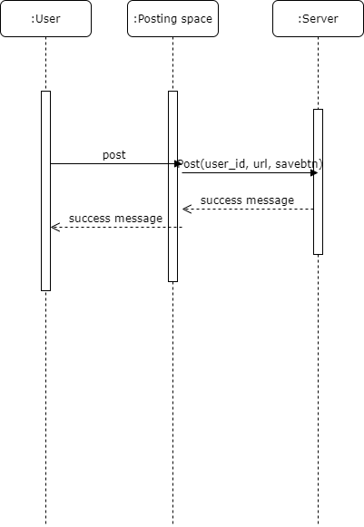

* + 1. Reading room
       1. Attributes

These are the attributes that reading room object has.

* **user_id**: id of the user (email address)
* **downbtn**: button to register an empty seat
* **upbtn**: button to leave out from the seat
* **Xbtn**: button to close the window guiding study time
* **rank**: high 10 users
  + - 1. Methods

These are the methods that reading room class has.

* Register(user_id, downbtn)
* Leave(user_id, upbtn)
* Close(Xbtn)
* ShowTime()
* ranking()
  + - 1. Class Diagram

[Diagram 46] Class diagram – Reading room

* + - 1. Sequence Diagram

[Diagram 47] Sequence diagram – Reading room

* + 1. Study room
       1. Attributes

These are the attributes that study room object has.

* **user_id**: id of the user (email address)
* **shareBoard**: screen board to share some data as image file
* **chatBoard**: discuss in the form of chat on the chatting board or voice
* **finishbtn**: button to leave out study room
* **whichRoom**: an empty study room chosen by the user
  + - 1. Methods

These are the methods that study room class has.

* Enter(user_id, whichRoom)
* Share(sharedBoard,data)
* Char(chatBoard, message)
* Leave(finishbtn)
  + - 1. Class Diagram

[Diagram 48] Class diagram – Study room

* + - 1. Sequence Diagram

[Diagram 49] Sequence diagram – Study room

* + 1. Exhibition
       1. Attributes

These are the attributes that exhibition object has.

* **user_id**: id of the user (email address)
* **savebtn**: button to post image or work
* **image**: url of image file where his/her post is uploaded
* **message**: message, impressions or questions about work
* **move**: button to leave out the exhibition hall
* **works**: the list of work from database
* **vote**: the number of times people clicked on a work
* **item**: hidden items in the descriptions of the work and the presentation videos
* **position**: the location of hidden items
  + - 1. Methods

These are the methods that exhibition class has.

* Enter(user_id)
* Post(user_id,image,savebtn)
* Write(user_id, message, savebtn)
* Show(image)
* Leave(move)
* Vote(user_id, image)
* Find(user_id, item, position)
  + - 1. Class Diagram

[Diagram 50] Class diagram – Exhibition

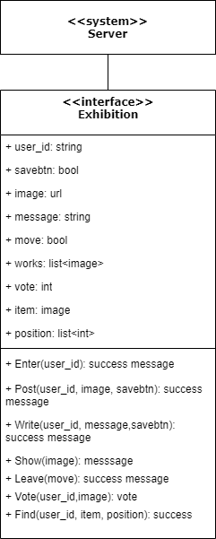

* + - 1. Sequence Diagram

[Diagram 51] Sequence diagram – Exhibition

* + 1. Event
       1. Attributes

These are the attributes that event object has.

* **user_id**: id of the user (email address)
* **item**: hidden item in the exhibition room
* **position**: the location of hidden items
  + - 1. Methods

These are the methods that event class has.

* Random(item)
* Find(user_id, item)
  + - 1. Class Diagram

[Diagram 52] Class diagram – Event

* + - 1. Sequence Diagram

[Diagram 53] Sequence diagram – Event

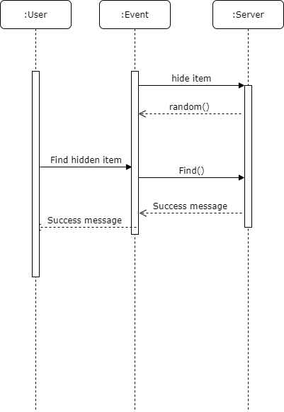

1. System Architecture - Backend
   1. Objectives

This contains information on the backend except for the frontend that makes direct contact with the user. It shows the structure in which the backend system and each subsystem are connected. It mainly represents a model and several subsystems in which the server runs.

* 1. Overall Architecture

The overall architecture of the system is as below.

[Figure 54] Overall architecture

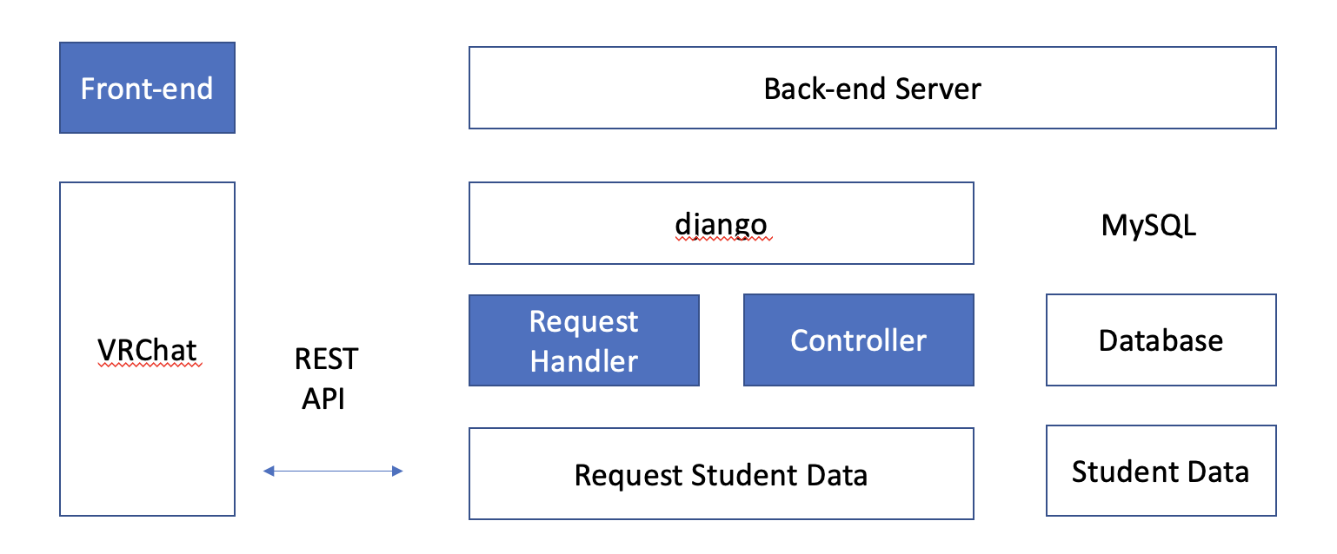

* 1. Subcomponent
     1. Server
        1. Class Diagram

The class diagram of server is as below.

[Diagram 55] Class diagram of server

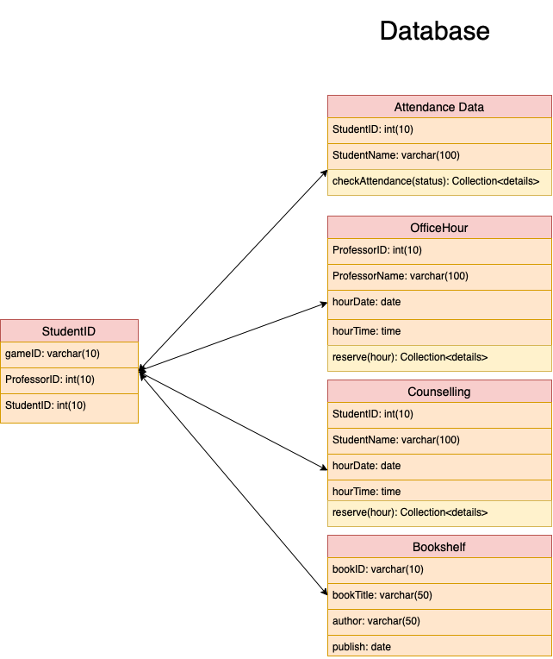

* + - 1. Sequence Diagram

The sequence diagram of server is as below.

[Diagram 56] Sequence diagram of server

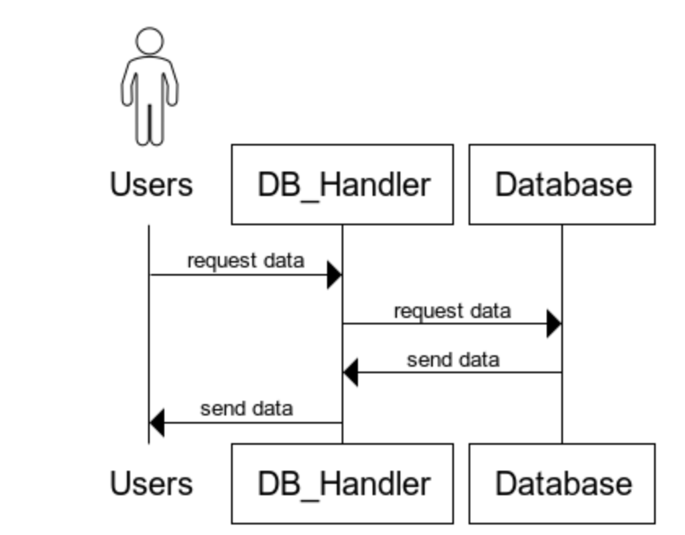

* + 1. Hub
       1. Class Diagram

Diagram below is the interface for Hub. It allows users to get a selection of games and movies. Also, the Hub system is related to the Chat class and Rest class.

[Diagram 57] Class diagram of Hub system

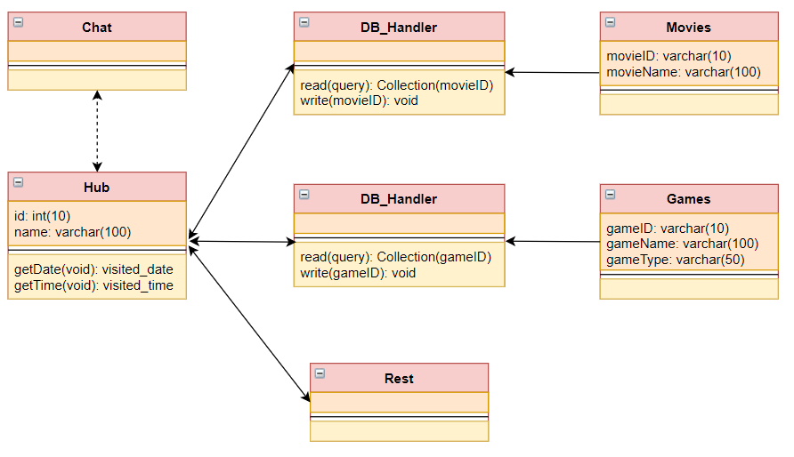

* + - 1. Sequence Diagram

[Diagram 58] Sequence diagram of movie system in Hub

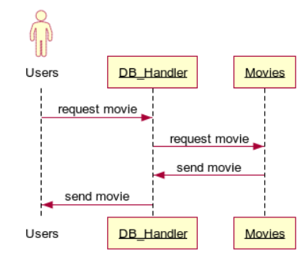

[Diagram 59] Sequence diagram of game system in Hub

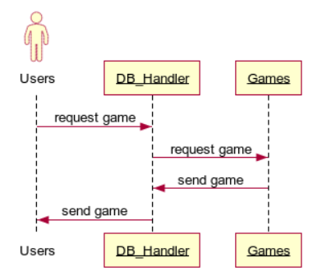

* + 1. Classroom
       1. Class Diagram

Interface for Classroom is shown as below diagram. It allows Professors to get counselling, attendance, office hour, and questions and answers information. Also, students are allowed to access the Bookshelf class to retrieve the books they want. Furthermore, in Counselling, Office Hour, and QA1 class, students are able to enter information for the respective purposes. In the Attendance class, there is a function to check the attendance of the students. Also, the Classroom system is related to the Chat class.

[Diagram 60] Class diagram of Classroom system

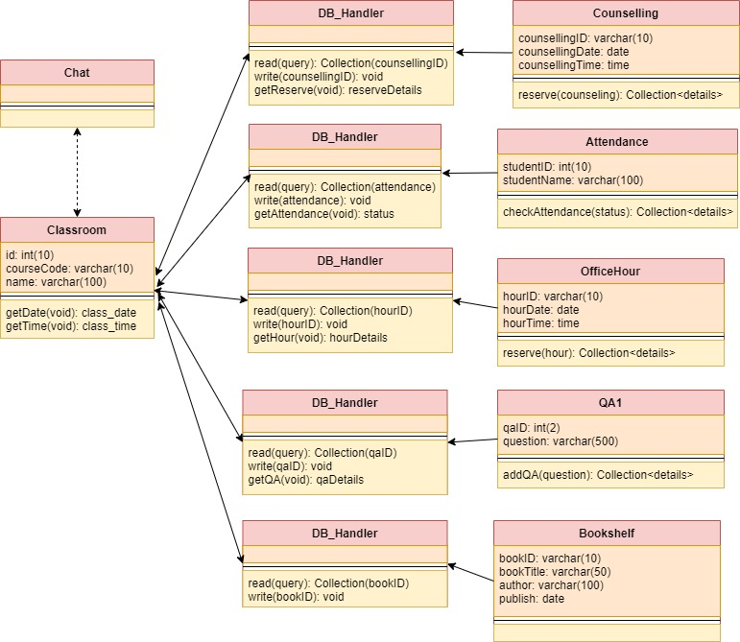

* + - 1. Sequence Diagram

[Diagram 61] Sequence diagram of Counseling system in Classroom

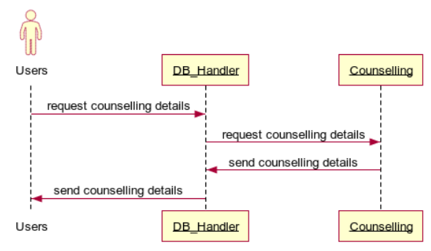

[Diagram 62] Sequence diagram of Attendance system in Classroom

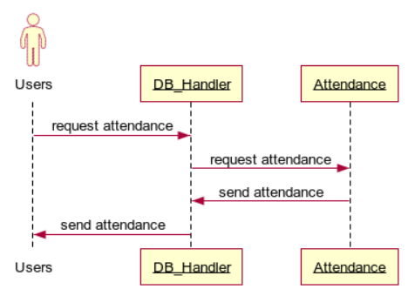

[Diagram 63] Sequence diagram of Office Hour system in Classroom

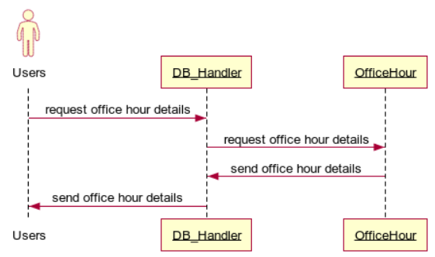

[Diagram 64] Sequence diagram of QA1 system in Classroom

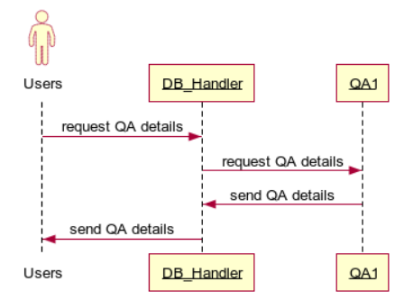

[Diagram 65] Sequence diagram of Bookshelf system in Classroom

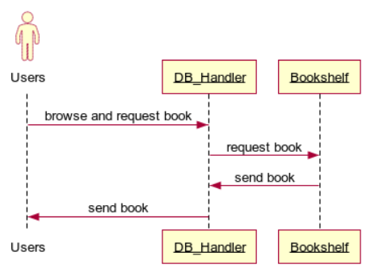

* + 1. Library
       1. Class Diagram

Below diagram shows the interface for Library. Students can browse and request for books for their choice by the Book class. Also, students can reserve study or reading room by the Rooms class. The Rooms class will first check the availability of the chosen room by Availability class before approving it to students. Also, the Library system is related to the Chat class.

[Diagram 66] Class diagram of Library system

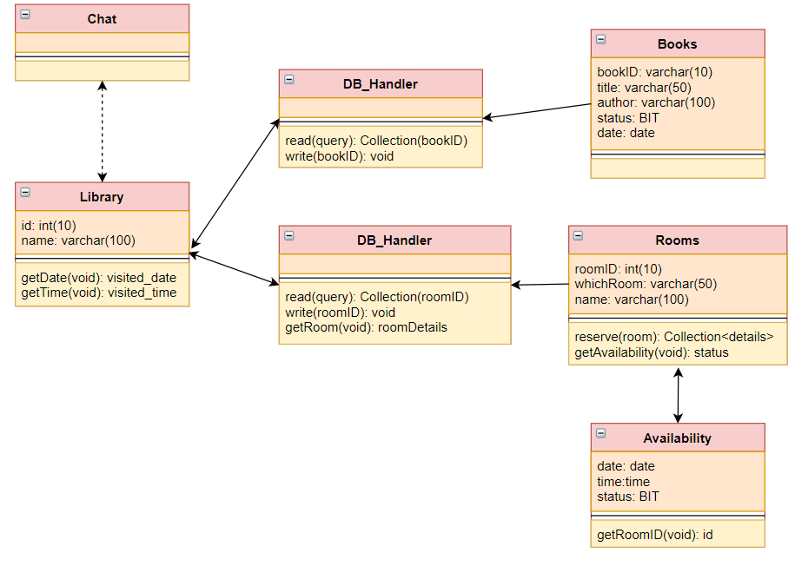

* + - 1. Sequence Diagram

[Diagram 67] Sequence diagram of Book system in Library

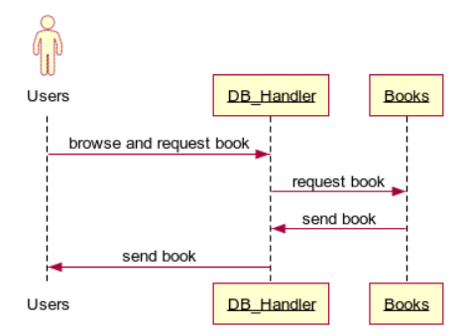

[Diagram 68] Sequence diagram of Rooms system in Library

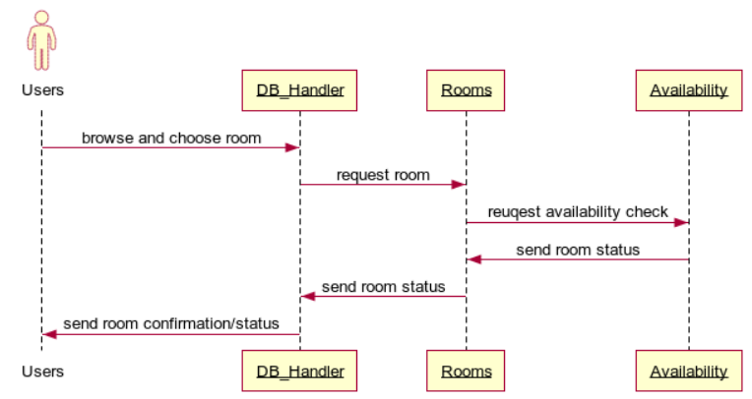

* + 1. Exhibition Hall
       1. Class Diagram

Here is the interface for Exhibition Hall. Students can browse through the ongoing exhibition by the Ongoing class. Furthermore, students can vote and ask questions about the exhibitions through the Vote and QA2 classes respectively. Also, the Exhibition Hall system is related to the Chat class.

[Diagram 69] Class diagram of Exhibition hall system

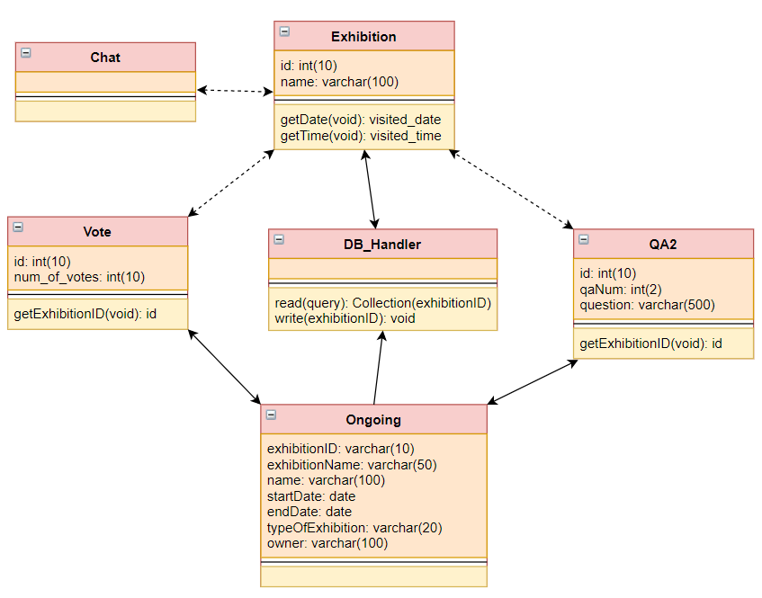

* + - 1. Sequence Diagram

[Diagram 70] Sequence diagram of Ongoing system in Exhibition hall

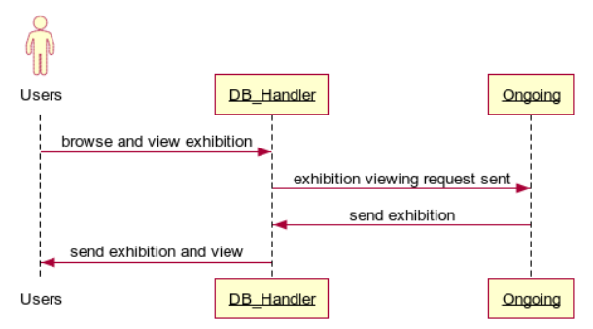

[Diagram 71] Sequence diagram of Vote system in Exhibition hall

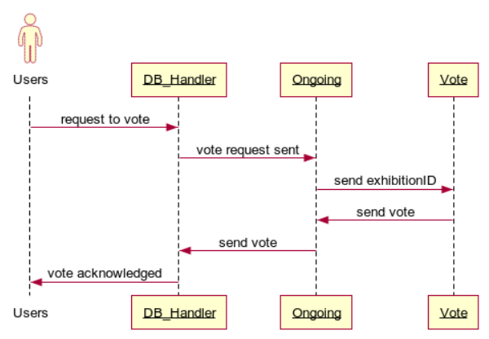

[Diagram 72] Sequence diagram of QA2 system in Exhibition hall

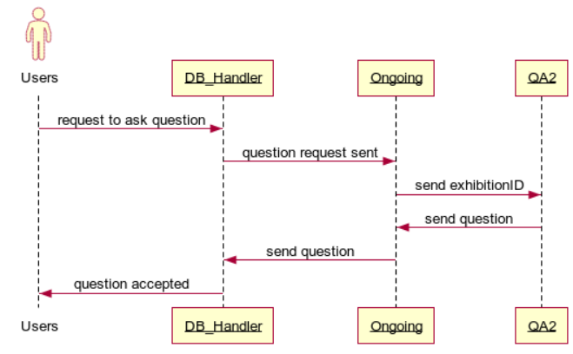

1. Protocol Design
   1. Objective

This chapter describes what structures are used for the protocols which are used for interaction between each subsystem, especially the Campus Hub and the server. Also, this chapter describes how each interface is defined.

* 1. JSON

JSON(JavaScript Object Notation) is an open standard file format, and data interchange format, that uses human-readable text to store and transmit data objects consisting of attribute–value pairs and array data types or any other serializable value. It is a very common data format, with a diverse range of applications, such as serving as a replacement for XML in AJAX systems.

All database data used in the Campus Hub is stored as JSON objects. Since the HTTP protocol is limited in VRChat, this service partially utilizes SQL database in table format. When needed data are crawled in JSON format, some of them would be parsed in related table data.

* 1. Details
     1. Authentication

Each user ID(student ID or professor ID) prove belong to the specific class or major. So far, users can approach to matched class which has a unique class number. User ID is a main identification factor of the user in the campus hub when they do something that need to link to database.

* + 1. Student information for class
       1. Planned Class
* Request

[Table 2] Table of class list request

| **Attribute** | **Detail** | |
| --- | --- | --- |
| Method | GET | |
| URI | /api/class/{id} | |
| Parameter | Basic information of class | |
| Request Body | Class_Lists | Class id |
| Header | Authorization | User authentication |

* Response

[Table 3] Table of class list response

| **Attribute** | **Detail** | |
| --- | --- | --- |
| Success Code | 200 OK | |
| Failure Code | HTTP error code = 404 (Not Found) | |
| Success  Response Body | Class_Lists | List objects |
| Failure  Response Body | message | Empty |

* + - 1. Class Attendance
* Request

[Table 4] Table of associated users of class request

| **Attribute** | **Detail** | |
| --- | --- | --- |
| Method | GET | |
| URI | /api/class/id/users | |
| Parameter | Class information (id) | |
| Request Body | Class_Attendance | User information (students, professor) |
| Header | Authorization | User authentication |

* Response

[Table 5] Table of associated users of class response

| **Attribute** | **Detail** | |
| --- | --- | --- |
| Success Code | 200 OK | |
| Failure Code | HTTP error code = 404 (Not Found) | |
| Success  Response Body | Class_Attendance | Associated Users List objects |
| Failure  Response Body | message | Empty |

* + 1. Movie in Hub

We would use utilize URL of Youtube video to watch movie.

* Request

[Table 6] Table of Youtube movie request

| **Attribute** | **Detail** | |
| --- | --- | --- |
| Method | GET | |
| URI | /api/movie | |
| Parameter | - | |
| Request Body | Movie_URL | url information of pre-stored Youtube video |
| Header | Authorization | User authentication |

* Response

[Table 7] Table of Youtube movie response

| **Attribute** | **Detail** | |
| --- | --- | --- |
| Success Code | 200 OK | |
| Failure Code | HTTP error code = 404 (Not Found) | |
| Success  Response Body | Movie_URL | Selected movie |
| Failure  Response Body | message | Empty |

* + 1. Book Information
       1. Bookshelves in Library
* Request

[Table 8] Table of book list request

| **Attribute** | **Detail** | |
| --- | --- | --- |
| Method | GET | |
| URI | /api/book | |
| Request Body | Book_Lists | - |
| Header | Authorization | User authentication |

* Response

[Table 9] Table of book list response

| **Attribute** | **Detail** | |
| --- | --- | --- |
| Success Code | 200 OK | |
| Failure Code | HTTP error code = 404 (Not Found) | |
| Success  Response Body | Book_Lists | Book objects |
| Failure  Response Body | message | Empty |

* + - 1. Get Book Information
* Request

[Table 10] Table of book information request

| **Attribute** | **Detail** | |
| --- | --- | --- |
| Method | GET | |
| URI | /api/book/{id} | |
| Parameter | Basic book information (id) of selected one | |
| Request Body | Book_Title | Title of book |
| Book_Author | Author of book |
| Book_Content | Content of book |
| Header | Authorization | User authentication |

* Response

[Table 11] Table of book information response

| **Attribute** | **Detail** | |
| --- | --- | --- |
| Success Code | 200 OK | |
| Failure Code | HTTP error code = 404 (Not Found) | |
| Success  Response Body | Book_Info | Selected book’s information such as title, author and content |
| Failure  Response Body | message | Empty |

* + - 1. Bookshelf in Classroom
* Request

[Table 12] Table of reference book information request

| **Attribute** | **Detail** | |
| --- | --- | --- |
| Method | GET | |
| URI | /api/class/book | |
| Request Body | Book_Lists | - |
| Header | Authorization | User authentication |

* Response

[Table 13] Table of reference book information response

| **Attribute** | **Detail** | |
| --- | --- | --- |
| Success Code | 200 OK | |
| Failure Code | HTTP error code = 404 (Not Found) | |
| Success  Response Body | Book_Lists | Book objects |
| Failure  Response Body | message | Empty |

* + - 1. Reference books in Classroom

All reference book used in classroom would be in library, therefore book information in bookshelf in classroom is from the same data table (in similar format) with **6.3.3.2**. Additionally, there can be registration of reference book in classroom.

* Request

[Table 14] Table of add reference book request

| **Attribute** | **Detail** | |
| --- | --- | --- |
| Method | POST | |
| URI | /api/class/book | |
| Request Body | Book_Title | Title of reference book |
| Book_Author | Author of reference book |
| Header | Authorization | User authentication |

* Response

[Table 15] Table of add reference book response

| **Attribute** | **Detail** | |
| --- | --- | --- |
| Success Code | 200 OK | |
| Failure Code | HTTP error code = 404 (Not Found) | |
| Success  Response Body | message | Success message |
| Failure  Response Body | message | Fail message |

* + 1. Posting space
       1. Read(All)
* Request

[Table 16] Table of posting list request

| **Attribute** | **Detail** | |
| --- | --- | --- |
| Method | GET | |
| URI | /api/posting | |
| Parameter | - | - |
| Header | Authorization | User authentication |
| Request Body | - | |

* Response

[Table 17] Table of posting list response

| **Attribute** | **Detail** | |
| --- | --- | --- |
| Success Code | 200 OK | |
| Failure Code | HTTP error code = 404 (Not Found) | |
| Success  Response Body | Posting_Lists | List objects |
| Failure  Response Body | message | Empty |

* + - 1. Read(Detail)
* Request

[Table 18] Table of detailed posting list request

| **Attribute** | **Detail** | |
| --- | --- | --- |
| Method | GET | |
| URI | /api/posting/{id} | |
| Parameter | Search_Posting | - |
| Header | Authorization | User authentication |
| Request Body | - | |

* Response

[Table 19] Table of detailed posting list response

| **Attribute** | **Detail** | |
| --- | --- | --- |
| Success Code | 200 OK | |
| Failure Code | HTTP error code = 404 (Not Found) | |
| Success  Response Body | Posting_Information | Information of posting objects |
| Failure  Response Body | message | Empty |

* + - 1. Create
* Request

[Table 20] Table of create posting request

| **Attribute** | **Detail** | |
| --- | --- | --- |
| Method | POST | |
| URI | /api/posting/{id} | |
| Parameter | Search_Posting | Posting object |
| Header | Authorization | User authentication |
| Request Body | Post_id | Id of posting |
| Content | Contents of posting |
| Title | Title of posting |

* Response

[Table 21] Table of create posting response

| **Attribute** | **Detail** | |
| --- | --- | --- |
| Success Code | 200 OK | |
| Failure Code | HTTP error code = 404 (Not Found) | |
| Success  Response Body | message | Success message |
| Failure  Response Body | message | Fail message |

* + - 1. Delete
* Request

[Table 22] Table of delete posting request

| **Attribute** | **Detail** | |
| --- | --- | --- |
| Method | DELETE | |
| URI | /api/posting/{id} | |
| Parameter | Query_id | Posting object that user wants to delete |
| Header | Authorization | User authentication |

* Response

[Table 23] Table of delete posting response

| **Attribute** | **Detail** | |
| --- | --- | --- |
| Success Code | 200 OK | |
| Failure Code | HTTP error code = 404 (Not Found) | |
| Success  Response Body | message | Success message |
| Failure  Response Body | message | Fail message |

* + - 1. Update
* Request

[Table 24] Table of update posting request

| **Attribute** | **Detail** | |
| --- | --- | --- |
| Method | PUT | |
| URI | /api/posting/{id} | |
| Request Body | Title | Title of posting (Information to change) |
| Content | Content of posting (Information to change) |
| Header | Authorization | User authentication |

* Response

[Table 25] Table of update posting response

| **Attribute** | **Detail** | |
| --- | --- | --- |
| Success Code | 200 OK | |
| Failure Code | HTTP error code = 404 (Not Found) | |
| Success  Response Body | message | Success message |
| Failure  Response Body | message | Fail message |

* + 1. Exhibition Hall
       1. Select exhibition
* Request

[Table 26] Table of read exhibition list request

| **Attribute** | **Detail** | |
| --- | --- | --- |
| Method | GET | |
| URI | /api/exhibition/ | |
| Parameter | - | - |
| Header | Authorization | User authentication |
| Request Body | - | |

* Response

[Table 27] Table of read exhibition list response

| **Attribute** | **Detail** | |
| --- | --- | --- |
| Success Code | 200 OK | |
| Failure Code | HTTP error code = 404 (Not Found) | |
| Success  Response Body | Exhibition_Lists | List objects |
| Failure  Response Body | message | Empty |

* + - 1. Enter exhibition and enjoy
* Request

[Table 28] Table of enter exhibition request

| **Attribute** | **Detail** | |
| --- | --- | --- |
| Method | GET | |
| URI | /api/exhibition/{exhibition name} | |
| Request Body | Search_Exhibition | Exhibition object |
| Header | Authorization | User authentication |

* Response

[Table 29] Table of enter exhibition response

| **Attribute** | **Detail** | |
| --- | --- | --- |
| Success Code | 200 OK | |
| Failure Code | HTTP error code = 404 (Not Found) | |
| Success  Response Body | Exhibition_Information | Information of posting objects |
| Failure  Response Body | message | Empty |

* + - 1. Create work
* Request

[Table 30] Table of create work request

| **Attribute** | **Detail** | |
| --- | --- | --- |
| Method | POST | |
| URI | /api/exhibition/{exhibition name}/{id} | |
| Parameter | Search_Exhibition | Exhibition object |
| Header | Authorization | User authentication |
| Request Body | Post_id | Id of work |
| Content | Contents of work |
| Title | Title of work |

* Response

[Table 31] Table of create work response

| **Attribute** | **Detail** | |
| --- | --- | --- |
| Success Code | 200 OK | |
| Failure Code | HTTP error code = 404 (Not Found) | |
| Success  Response Body | message | Success message |
| Failure  Response Body | message | Fail message |

* + - 1. Delete work
* Request

[Table 32] Table of delete work request

| **Attribute** | **Detail** | |
| --- | --- | --- |
| Method | DELETE | |
| URI | /api/exhibition/{exhibition name}/{id} | |
| Request Body | Query_id | Work object that user wants to delete |
| Header | Authorization | User authentication |

* Response

[Table 33] Table of delete work response

| **Attribute** | **Detail** | |
| --- | --- | --- |
| Success Code | 200 OK | |
| Failure Code | HTTP error code = 404 (Not Found) | |
| Success  Response Body | message | Success message |
| Failure  Response Body | message | Fail message |

* + - 1. Update
* Request

[Table 34] Table of update work request

| **Attribute** | **Detail** | |
| --- | --- | --- |
| Method | PUT | |
| URI | /api/exhibition/{exhibition name}/{id} | |
| Request Body | Title | Title of work (Information to change) |
| Content | Content of work (Information to change) |
| Header | Authorization | User authentication |

* Response

[Table 35] Table of update work response

| **Attribute** | **Detail** | |
| --- | --- | --- |
| Success Code | 200 OK | |
| Failure Code | HTTP error code = 404 (Not Found) | |
| Success  Response Body | message | Success message |
| Failure  Response Body | message | Fail message |

1. Database Design
   1. Objective

This section describes the system data structures and how these are to be represented in a database. It first identifies entities and their relationship through ER-diagram (Entity Relationship diagram). Then, it generates Relational Schema and SQL DDL (Data Description Language) specification.

* 1. ER Diagram

The system consists of five entities; Users, Classroom, Hub, Exhibition Hall, and Library. ER-diagram expresses each entity as rectangular and their relationship as rhombus. When an entity has multiple relationship with another entity, trident (three line) is used to indicate it. When an entity has just one relationship with another entity, the cross (two line) is used to indicate it. When an entity is of optional relationship with another entity, an oval is used to indicate it. The attribute of an entity is expressed as an ellipse. The unique attribute which uniquely identifies an entity is underlined. The composite attributes which uniquely identifies an entity are in brackets.

[Diagram 73] ER Diagram

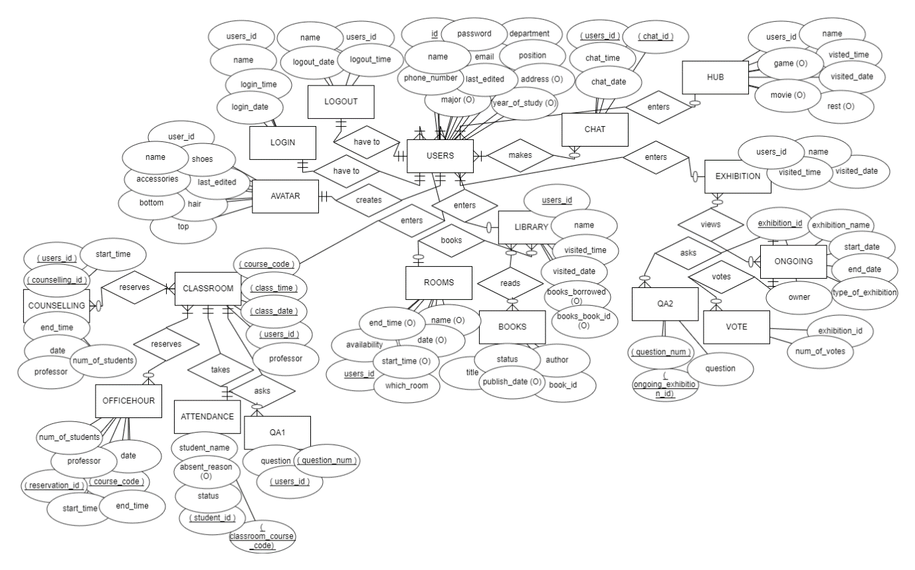

* + 1. Entities
       1. User

USERS and LOGOUT relationship is that all users are only allowed to one logout and it is mandatory to logout. USERS and LOGIN relationship is that all users are only allowed to one login and it is mandatory to login. USERS and AVATAR relationship is that all users are only allowed to one avatar and it is a must to create the avatar. USERS and CHAT relationship is that many users can be in the same chat room and many chat rooms can be used by one user. Also, using the chat room is not mandatory.

[Diagram 74] ER diagram, Entity, User

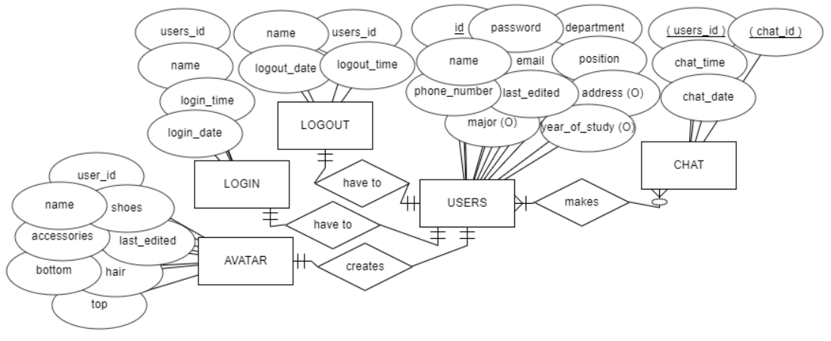

* + - 1. Classroom

CLASSROOM and COUNSELLING relationship is that a user in the classroom can reserve many counselling sessions and a counselling room can be used by many users but using the counselling room is not a must. CLASSROOM and OFFICEHOUR relationship is that a user in the classroom can reserve many office hour sessions and an office hour session can be used by many users but having an office hour is not a must. CLASSROOM and ATTENDANCE relationship is that all students must take their attendance and all students can only take attendance for him or herself only. CLASSROOM and QA1 relationship is that a user can ask many questions and a question must be asked by at least a user; however, asking a question is not mandatory.

[Diagram 75] ER diagram, Entity, Classroom

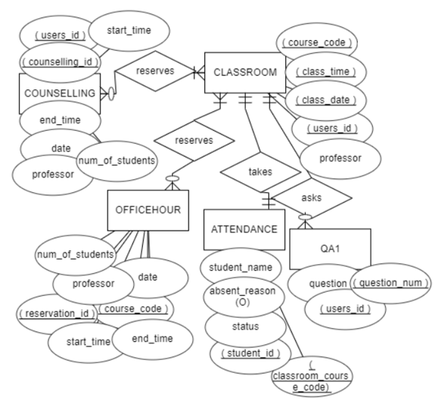

* + - 1. Hub

The HUB entity does not have any sub-entities but the HUB is connected with the USER entity whereby the hub can be entered by many users but it is not mandatory to enter the hub.

[Diagram 76] ER diagram, Entity, Hub

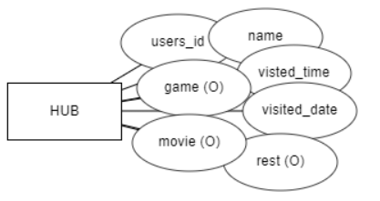

* + - 1. Exhibition Hall

EXHIBITION and ONGOING relationship is that a user can view many ongoing exhibitions and an ongoing exhibition can be viewed by many users. Also, it is not a must to view an exhibition and an exhibition may not be viewed by any users too. ONGOING and QA2 relationship is that a user can ask many questions about an exhibition and an exhibition’s question must be asked by at least a user; however, asking a question is not mandatory. ONGOING and VOTE relationship is that a user can vote many exhibitions and an exhibition must be vote by only users; however, voting is not mandatory.

[Diagram 77] ER diagram, Entity, Exhibition Hall

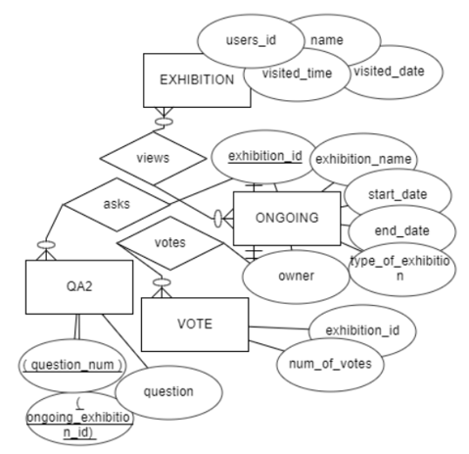

* + - 1. Library

LIBRARY and ROOMS relationship is such that a user in the library can reserve many rooms and a room can only be reserved by a user. Also, it is not a must to reserve a room. BOOKS and LIBRARY relationship is such that a user in the library can read many books and a book can be shared and read by many users; however, it is optional to read a book when entering the library.

[Diagram 78] ER diagram, Entity, Library

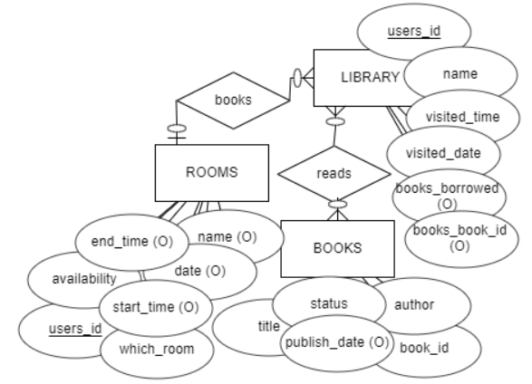

* + 1. Relational Schema

[Figure 79] Relational Schema

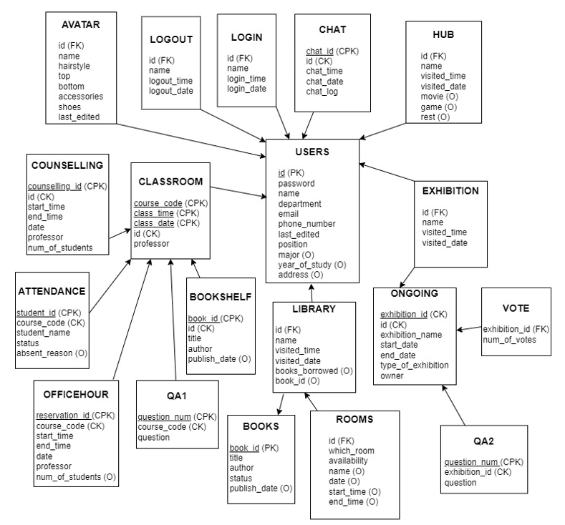

* + 1. SQL DDL
       1. Users

|  |
| --- |
| CREATE TABLE USERS (  id INT NOT NULL,  password VARCHAR(15) NOT NULL,  name VARCHAR(100) NOT NULL,  department VARCHAR(20) NOT NULL,  email VARCHAR(20) NOT NULL,  phone_number INT NOT NULL,  last_edited DATE NOT NULL,  position VARCHAR(10) NOT NULL,  major VARCHAR(20),  year_of_study INT,  address VARCHAR(100),  PRIMARY KEY (id)  ); |

* + - 1. Avatar

|  |
| --- |
| CREATE TABLE AVATAR (  users_id INT NOT NULL,  name VARCHAR(100) NOT NULL,  hairstyle VARCHAR(100) NOT NULL,  top VARCHAR(100) NOT NULL,  bottom VARCHAR(100) NOT NULL,  accessories VARCHAR(100) NOT NULL,  shoes VARCHAR(100) NOT NULL,  last_edited DATE NOT NULL,  PRIMARY KEY (users_id),  FOREIGN KEY (users_id) REFERENCES USERS(id)  ); |

* + - 1. Logout

|  |
| --- |
| CREATE TABLE LOGOUT (  users_id INT NOT NULL,  name VARCHAR(100) NOT NULL,  logout_time TIME NOT NULL,  logout_date DATE NOT NULL,  PRIMARY KEY (users_id),  FOREIGN KEY (users_id) REFERENCES USERS(id)  ); |

* + - 1. Login

|  |
| --- |
| CREATE TABLE LOGIN (  users_id INT NOT NULL,  name VARCHAR(100) NOT NULL,  login_time TIME NOT NULL,  login_date DATE NOT NULL,  PRIMARY KEY (users_id),  FOREIGN KEY (users_id) REFERENCES USERS(id)  ); |

* + - 1. Chat

|  |
| --- |
| CREATE TABLE CHAT (  users_id INT NOT NULL,  chat_id INT NOT NULL,  chat_time TIME NOT NULL,  chat_date DATE NOT NULL,  chat_log VARCHAR(500) NOT NULL,  PRIMARY KEY (users_id, chat_id),  FOREIGN KEY (users_id) REFERENCES USERS(id)  ); |

* + - 1. Hub

|  |
| --- |
| CREATE TABLE HUB (  users_id INT NOT NULL,  name VARCHAR(100) NOT NULL,  visited_time TIME NOT NULL,  visited_date DATE NOT NULL,  movie BIT,  game BIT,  rest BIT,  PRIMARY KEY (users_id),  FOREIGN KEY (users_id) REFERENCES USERS(id)  ); |

* + - 1. Classroom

|  |
| --- |
| CREATE TABLE CLASSROOM (  users_id INT NOT NULL,  course_code VARCHAR(10) NOT NULL UNIQUE,  class_time TIME NOT NULL,  class_date DATE NOT NULL,  professor VARCHAR(100) NOT NULL,  PRIMARY KEY (users_id, course_code, class_time, class_date),  FOREIGN KEY (users_id) REFERENCES USERS(id)  ); |

* + - 1. Counseling

|  |
| --- |
| CREATE TABLE COUNSELING (  counseling_id INT NOT NULL,  classroom_course_code VARCHAR(10) NOT NULL,  start_time TIME NOT NULL,  end_time TIME NOT NULL,  date DATE NOT NULL,  professor VARCHAR(100) NOT NULL,  num_of_students INT NOT NULL,  PRIMARY KEY (counseling_id, classroom_course_code),  FOREIGN KEY (classroom_course_code) REFERENCES CLASSROOM(course_code)  ); |

* + - 1. Attendance

|  |
| --- |
| CREATE TABLE ATTENDANCE (  classroom_course_code VARCHAR(10) NOT NULL,  student_id INT NOT NULL,  student_name VARCHAR(100) NOT NULL,  status BIT NOT NULL,  absent_reason VARCHAR(50),  PRIMARY KEY (classroom_course_code, student_id),  FOREIGN KEY (classroom_course_code) REFERENCES CLASSROOM(course_code)  ); |

* + - 1. Bookshelf

|  |
| --- |
| CREATE TABLE BOOKSHELF (  book_id VARCHAR(10) NOT NULL,  classroom_course_code VARCHAR(10) NOT NULL,  title VARCHAR(50) NOT NULL,  author VARCHAR(100) NOT NULL,  publish_date DATE,  PRIMARY KEY (book_id, classroom_course_code),  FOREIGN KEY (classroom_course_code) REFERENCES CLASSROOM (course_code)  ); |

* + - 1. Office Hour

|  |
| --- |
| CREATE TABLE OFFICEHOUR (  reservation_id INT NOT NULL,  classroom_course_code VARCHAR(10) NOT NULL,  start_time TIME NOT NULL,  end_time TIME NOT NULL,  date DATE NOT NULL,  professor VARCHAR(100) NOT NULL,  num_of_students INT,  PRIMARY KEY (reservation_id, classroom_course_code),  FOREIGN KEY (classroom_course_code) REFERENCES CLASSROOM(course_code)  ); |

* + - 1. QA1

|  |
| --- |
| CREATE TABLE QA1 (  classroom_course_code VARCHAR(10) NOT NULL,  question_num INT NOT NULL,  question VARCHAR(500) NOT NULL,  PRIMARY KEY (classroom_course_code, question_num),  FOREIGN KEY (classroom_course_code) REFERENCES CLASSROOM(course_code)  ); |

* + - 1. Library

|  |
| --- |
| CREATE TABLE LIBRARY (  users_id INT NOT NULL,  books_book_id VARCHAR(10) NOT NULL,  name VARCHAR(100) NOT NULL,  visited_time TIME NOT NULL,  visited_date DATE NOT NULL,  books_borrowed VARCHAR(50),  PRIMARY KEY (users_id, books_book_id),  FOREIGN KEY (users_id) REFERENCES USERS(id),  FOREIGN KEY (books_book_id) REFERENCES BOOKS(book_id)  ); |

* + - 1. Books

|  |
| --- |
| CREATE TABLE BOOKS (  book_id VARCHAR(10) NOT NULL,  title VARCHAR(50) NOT NULL,  author VARCHAR(100) NOT NULL,  status BIT NOT NULL,  publish_date DATE,  PRIMARY KEY (book_id)  ); |

* + - 1. Rooms

|  |
| --- |
| CREATE TABLE ROOMS (  users_library_id INT NOT NULL,  which_room VARCHAR(50) NOT NULL,  availability BIT NOT NULL,  name VARCHAR(100),  date DATE,  start_time TIME,  end_time TIME,  PRIMARY KEY (users_library_id),  FOREIGN KEY (users_library_id) REFERENCES LIBRARY(users_id)  ); |

* + - 1. Exhibition

|  |
| --- |
| CREATE TABLE EXHIBITION (  users_id INT NOT NULL,  name VARCHAR(100) NOT NULL,  visited_time TIME NOT NULL,  visited_date DATE NOT NULL,  PRIMARY KEY (users_id),  FOREIGN KEY (users_id) REFERENCES USERS(id)  ); |

* + - 1. Ongoing

|  |
| --- |
| CREATE TABLE ONGOING (  exhibition_id VARCHAR(10) NOT NULL,  exhibition_name VARCHAR(50) NOT NULL,  start_date DATE NOT NULL,  end_date DATE NOT NULL,  type_of_exhibition VARCHAR(20) NOT NULL,  owner VARCHAR(100) NOT NULL,  PRIMARY KEY (exhibition_id)  ); |

* + - 1. Vote

|  |
| --- |
| CREATE TABLE VOTE (  ongoing_exhibition_id VARCHAR(10) NOT NULL,  num_of_votes INT NOT NULL,  PRIMARY KEY (ongoing_exhibition_id),  FOREIGN KEY (ongoing_exhibition_id) REFERENCES ONGOING(exhibition_id)  ); |

* + - 1. QA2

|  |
| --- |
| CREATE TABLE QA2 (  ongoing_exhibition_id VARCHAR(10) NOT NULL,  question_num INT NOT NULL,  question VARCHAR(500) NOT NULL,  PRIMARY KEY (ongoing_exhibition_id, question_num),  FOREIGN KEY (ongoing_exhibition_id) REFERENCES ONGOING(exhibition_id)  ); |

1. Testing Plan
   1. Objective

The purpose of testing's planning and planning is to find defects and errors that may appear during or after system development, correct them, and evaluate whether the system has been developed according to the planned intention or its performance is appropriate. In addition, the pre-planned testing plan will provide some guidelines for development. The testing plan will be largely carried out in three stages: development testing, release testing, and user testing. These tests are very important in that they detect potential errors and defects in the product, have perfect operation, and reliably launch the product to the market and customers.

* 1. Testing Policy
     1. Development Testing

Development tests during development can be unstable and components can collide with each other because the software has not been tested sufficiently. Therefore, this step focuses on sub-system evaluation and requires static code an Through this process, we will conduct the evaluation based on performance, reliability, and usability.

* + - 1. Performance

As many users access Campus Hub at the same time and enjoy Campus life, it is important to provide services provided by The Campus Hub, such as lectures and books, without delay. In order to provide services that do not require databases such as space movement, lectures, and microphones within 5 seconds, and services that require databases such as book loans and returns and exhibitions within 10 seconds, we will prepare various test cases to measure each reaction speed and evaluate the efficient system communication.

* + - 1. Reliability

The system operates safely without failure. Because it integrates various functions such as lecture rooms, hubs, libraries, and exhibition rooms, not only should the components and units of the place in The Campus Hub work correctly, but also should be free from errors in the process of moving to the place. Therefore, the development test should be conducted from the integration stage to check the failure repeatedly.

* + - 1. Usability

The Campus Hub should be easy to use and configured to minimize user errors even for all users, including the first user. The use of technical terms should be minimized, and if necessary, it should be explained easily. Each user should be able to use all system functions instinctively without training time, that is, without a guide page. That is, the user interface should be simple, intuitive, and easy to use. To this end, we would like to select tests of about 10 people in user testing and survey the user experience of the application.

* + - 1. Security

Securing information of users and the system is a crucial matter to be handled by developers. Regardless of the value of the information, it should be protected from unwanted visitors to the system.

This system is a community of students from the same university. So, the users should be properly authenticated before using the system. It should make sure that an unauthorized user cannot gains access as system manager and makes system unavailable. Therefore, it is necessary to ensure that the school is authenticated to prevent unrelated users from joining the system. Because vrchat or steam's own membership registration system is used for basic user registration, it takes a reliable step in security. Also, an unauthorized user cannot gain access as system user to confidential information such as user’s personal Information, ID, and password. Only authenticated users can modify profiles, move spaces, and chat. In addition, only users who have registered for the class can participate in the classroom. In addition, not only students but also professors who meet students in classrooms and office hours zones must go through an accurate verification process so that only authorized people can use it. Users who are not reserved are not allowed to enter the study room. Only users who borrowed the book can access the book.

* + 1. Release Testing

One of the most critical parts of any software development project is to release the product to the market, and customers.

A technically good software can go wrong due to a wrong way of release. Therefore, release testing is inevitable for better connection between the product and the market. Release testing is testing a new version of a software/application to verify that that the software can be released in a flawless and doesn`t have any issues and works as intended. It should be carried out before release.

Based on Software Release Life Cycle, testing is generally initiated from the ‘Alpha’ version, where a basic implementation of the software is completed. We would start development testing in Alpha version, and release Beta version for the further testing including user and release testing.

[Figure 80] Software Release Life Cycle

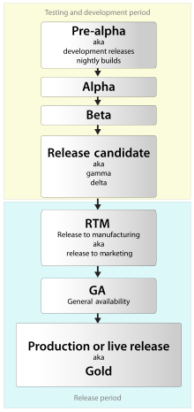

* + 1. User Testing

This step tests the system in the user's real-world environment. User testing can be explained by the concept of usability testing. We should set up scenario and realistic situation that can proceed necessary user tests. Assume that 20 users are testing The Campus hub. After setting this situation, we would distribute Beta version of The Campus Hub to them Along with feedback from users, you will hear various reviews such as whether it is similar to the real environment or the unique features of our system. At the same time as the open beta, we will also conduct a close beta to test it from the developer's point of view and find points to fix.

* + 1. Testing Case

Testing case would be set according to 3 fundamental aspects of the application– function(interaction), performance, and security. We would set several testcases for each part of our services and proceed testing on The Campus Hub with the evaluation sheet. Here is the some examples.

* Login Service
  + Does the Login Service work normally? ex) e-mail format, duplicate, password format
* Set Profile
  + Does it look normal when the user applies Avatar?
  + In case of various errors such as information conflict between users and the format of the information in the profile
* Hub
  + Is moving to another space proceeding normally?
  + Is it possible to match users or import data from functions such as movies and games in the entertainment area without errors?
* Classroom
  + Is it possible for users to enter and leave the classroom according to their timetable?
  + Is it possible to use without errors when using bookshelf?
  + When using the office hour zone, does the function to confirm the reservation with the user's id and check whether it has been processed in advance?
* Library
  + Does the function to check the user's ID when entering the library work properly?
  + Are various functions of the library such as group study, seat reservation, and study room functioning normally?
* Exhibition hall
  + Since various data are displayed according to the name of the exhibition, is it normally displayed to users?
  + How do the functions that leave user reviews for various works, such as writing support messages, leaving questions, and leaving gifts, work properly?
  + Are the features that users vote for their favorite works and give gifts through various events working properly?

1. Development Plan
   1. Objective

This chapter illustrates the environments programs, and plugins for the Unity which we will use for the development. Main development will be on Unity and other programs will be used to support the development on Unity.

* 1. Frontend Environment
     1. Photoshop

Photoshop is a raster graphics editor developed and published by Adobe Inc. for Windows and macOS. Photoshop can edit and compose raster images in multiple layers and supports masks, alpha compositing and several color models including RGB, CMYK, CIELAB, spot color, and duotone. This program could provide texture adjustment or creation during our project. We will use multiple 3d models in unity, and we should edit the textures

[Figure 81] Adobe Photoshop logo



* + 1. Blender

Blender is a free and open-source 3D computer graphics software toolset used for creating animated films, visual effects, art, 3D printed models, motion graphics, interactive 3D applications, virtual reality, and computer games. Blender’s features include 3D modeling, UV unwrapping, texturing, raster graphics editing, rigging and skinning, fluid and smoke simulation, particle simulation, soft body simulation, sculpting, animating, match moving, rendering, motion graphics, video editing, and compositing. We will likely to use 3D model editing and UV unwrapping and rigging feature. Blender is open-source free program so we chose this to be used.

[Figure 82] Blender logo



* + 1. Unity2019

Unity is a cross-platform game engine developed by Unity Technologies. The engine supports a variety of desktop, mobile, console and virtual reality platforms. It is popular for iOS and Android mobile game development and used for many games. VRChat currently support Unity’s development environment. We will use Unity 2019.4.30f to develop our project.

[Figure 83] Unity2019 logo



* + 1. UdonSharp

UdonSharp is a compiler that compiles C# to Udon assembly which is a programming language built by VRChat development team. We could develop VRChat’s world by built in Udon Graph program which is made by VRChat development team, but there are many restrictions. Udon Graph is for the users who are not familiar at the programming languages so it is very inefficient to programmers like our team. UdonSharp is far better way to develop VRChat world for the programmers. So we chose this plugin to develop our project.

[Figure 84] UdonSharp logo



* 1. Backend Environment
     1. Github

It provides hosting for software development version control using Git. It enables teammates to develop a single project together, resulting in easy integration of components. We are now using GitHub for developing The Campus Hub and controlling version of it.

[Figure 85] Github logo



* + 1. MySQL

MySQL is the world's most popular open source relational database management system (RDBMS). It is a multi-threaded, multi-user structured query language database management system, managed and supported by Oracle. In this system, MySQL will be used as the RDBMS that manages the database of the backend application. This is because MySQL has been used by many people for a long time, so there are various sources, and team members are more familiar with MySQL.

[Figure 86] MySQL logo



* + 1. Youtube

YouTube is a video sharing platform provided by Google. As the world's largest video sharing and hosting site, users can watch, upload, and share videos. Since the types of video players that can be used within the VR chat are limited, we decided to access the necessary link or url through youtube, which is cost-free and easy to use.

[Figure 87] Youtube logo



* + 1. Django

Django is a Python-based open-source web framework that follows the Model-View-Controller (MVC) pattern. The advantage of Djagno is that the components are highly reusable and can be developed quickly, because there are various functions that support easy solving of various problems such as database management and security problems. Django is currently used as a web framework in various places such as Instagram, Disqus, and Mozilla, and Django was used when writing the Backend Application in this system.

[Figure 88] Django logo



* 1. Schedule

[Table 36] Schedule

| **Phase** | **Expected** | **Actual** |
| --- | --- | --- |
| Concept & Proposal | 21.09.26 | 21.09.26 |
| Requirements Specification | 21.10.24 | 21.10.24 |
| Design Documentation | 21.11.21 | 21.11.21 |
| Environment Setting | 21.11.12 | 21.11.12 |
| Frontend Development | ~21.11.26 |  |
| Backend – | ~21.11.28 |  |
| System Integration and Testing | ~21.11.30 |  |

1. Index
   1. Table Index

[Table 1] Document History 12

[Table 2] Table of class list request 82

[Table 3] Table of class list response 82

[Table 4] Table of associated users of class request 82

[Table 5] Table of associated users of class response 83

[Table 6] Table of Youtube movie request 83

[Table 7] Table of Youtube movie response 83

[Table 8] Table of book list request 84

[Table 9] Table of book list response 84

[Table 10] Table of book information request 85

[Table 11] Table of book information response 85

[Table 12] Table of reference book information request 85

[Table 13] Table of reference book information response 86

[Table 14] Table of add reference book request 86

[Table 15] Table of add reference book response 87

[Table 16] Table of posting list request 87

[Table 17] Table of posting list response 87

[Table 18] Table of detailed posting list request 88

[Table 19] Table of detailed posting list response 88

[Table 20] Table of create posting request 88

[Table 21] Table of create posting response 89

[Table 22] Table of delete posting request 89

[Table 23] Table of delete posting response 90

[Table 24] Table of update posting request 90

[Table 25] Table of update posting response 90

[Table 26] Table of read exhibition list request 91

[Table 27] Table of read exhibition list response 91

[Table 28] Table of enter exhibition request 91

[Table 29] Table of enter exhibition response 92

[Table 30] Table of create work request 92

[Table 31] Table of create work response 93

[Table 32] Table of delete work request 93

[Table 33] Table of delete work response 93

[Table 34] Table of update work request 94

[Table 35] Table of update work response 94

[Table 36] Schedule 119

* 1. Figure Index

[Diagram 1] Context model 18

[Diagram 2] Sequence diagram 19

[Diagram 3] Use case diagram 19

[Diagram 4] Class diagram – Entering the campus hub 21

[Diagram 5] Sequence diagram – Entering the campus hub 22

[Diagram 6] Class diagram – Profile 24

[Diagram 7] Sequence diagram – Profile 24

[Diagram 8] Class diagram – Space movement 26

[Diagram 9] Sequence diagram – Space movement 26

[Diagram 10] Class diagram – Upload file 27

[Diagram 11] Sequence diagram – Upload file 28

[Diagram 12] Class diagram – Chat 29

[Diagram 13] Sequence diagram – Chat 30

[Diagram 14] Class diagram – Hub 31

[Diagram 15] Sequence diagram – Hub 31

[Diagram 16] Class diagram – Game 32

[Diagram 17] Sequence diagram – Game 33

[Diagram 18] Class diagram – Movie 34

[Diagram 19] Sequence diagram – Movie 35

[Diagram 20] Class diagram – Beanbag 36

[Diagram 21] Sequence diagram – Beanbag 36

[Diagram 22] Class diagram – Classroom 38

[Diagram 23] Sequence diagram – Classroom 38

[Diagram 24] Class diagram – Attendance 39

[Diagram 25] Sequence diagram – Attendance 40

[Diagram 26] Class diagram – Screenboard 41

[Diagram 27] Sequence diagram – Screenboard 41

[Diagram 28] Class diagram – Desk 43

[Diagram 29] Sequence diagram – Desk 43

[Diagram 30] Class diagram – Automatic classroom enter 44

[Diagram 31] Sequence diagram – Automatic classroom enter 45

[Diagram 32] Class diagram – Reservation 46

[Diagram 33] Sequence diagram – Reservation 46

[Diagram 34] Class diagram – Officehour 48

[Diagram 35] Sequence diagram – Officehour 48

[Diagram 36] Class diagram – Counseling 49

[Diagram 37] Sequence diagram – Counseling 49

[Diagram 38] Class diagram – Bookshelf in classroom 51

[Diagram 39] Sequence diagram – Bookshelf in classroom 52

[Diagram 40] Class diagram – Elevator 54

[Diagram 41] Sequence diagram – Elevator 55

[Diagram 42] Class diagram – Bookshelves in Library 56

[Diagram 43] Sequence diagram – Bookshelves in Library 57

[Diagram 44] Class diagram – Posting space 59

[Diagram 45] Sequence diagram – Posting space 59

[Diagram 46] Class diagram – Reading room 61

[Diagram 47] Sequence diagram – Reading room 62

[Diagram 48] Class diagram – Study room 63

[Diagram 49] Sequence diagram – Study room 64

[Diagram 50] Class diagram – Exhibition 66

[Diagram 51] Sequence diagram – Exhibition 67

[Diagram 52] Class diagram – Event 69

[Diagram 53] Sequence diagram – Event 69

[Figure 54] Overall architecture 71

[Diagram 55] Class diagram of server 71

[Diagram 56] Sequence diagram of server 72

[Diagram 57] Class diagram of Hub system 73

[Diagram 58] Sequence diagram of movie system in Hub 73

[Diagram 59] Sequence diagram of game system in Hub 73

[Diagram 60] Class diagram of Classroom system 74

[Diagram 61] Sequence diagram of Counseling system in Classroom 75

[Diagram 62] Sequence diagram of Attendance system in Classroom 75

[Diagram 63] Sequence diagram of Office Hour system in Classroom 76

[Diagram 64] Sequence diagram of QA1 system in Classroom 76

[Diagram 65] Sequence diagram of Bookshelf system in Classroom 76

[Diagram 66] Class diagram of Library system 77

[Diagram 67] Sequence diagram of Book system in Library 78

[Diagram 68] Sequence diagram of Rooms system in Library 78

[Diagram 69] Class diagram of Exhibition hall system 79

[Diagram 70] Sequence diagram of Ongoing system in Exhibition hall 80

[Diagram 71] Sequence diagram of Vote system in Exhibition hall 80

[Diagram 72] Sequence diagram of QA2 system in Exhibition hall 80

[Diagram 73] ER Diagram 95

[Diagram 74] ER diagram, Entity, User 96

[Diagram 75] ER diagram, Entity, Classroom 97

[Diagram 76] ER diagram, Entity, Hub 98

[Diagram 77] ER diagram, Entity, Exhibition Hall 99

[Diagram 78] ER diagram, Entity, Library 99

[Figure 79] Relational Schema 100

[Figure 80] Software Release Life Cycle 112

[Figure 81] Adobe Photoshop logo 115

[Figure 82] Blender logo 116

[Figure 83] Unity2019 logo 116

[Figure 84] UdonSharp logo 117

[Figure 85] Github logo 117

[Figure 86] MySQL logo 118

[Figure 87] Youtube logo 118

[Figure 88] Django logo 119